A Universal Plug-and-Play Edge-AI Platform for Privacy-Preserving Healthcare Applications

MAJOR PROJECT REPORT
Submitted to
COLLEGE OF ENGINEERING &TECHNOLOGY
In partial fulfillment of the requirements for the award of the degree of
BACHELOR OF TECHNOLOGY
in
Biomedical Engineering
By
BIBEK RAM (RA2211013010119)
ABHISHEK KUMAR JHA (RA2211013010120)
SURAJ PRASAD SAH (RA2211013010093)

Under the guidance of
Dr. U. Snekhalatha
Prof and Head of Department
Department of Biomedical Engineering

COLLEGE OF ENGINEERING AND TECHNOLOGY
S.R.M. Nagar, Kattankulathur, Kancheepuram District
SRM INSITUTE OF SCIENCE AND TECHNOLOGY
(Deemed to be University
Under Section 3 of UGC Act, 1956)
MAY 2026

ACKNOWLEDGEMENT
First and foremost, we express our heartfelt and deep sense of gratitude to our Chancellor, Shri. T. R. Pachaimuthu, The Pro-Chancellor (Administration) of SRMIST, Dr. P. Ravi, and the Pro-Chancellor (Academics) Dr. P. Sathyanarayanan, Vice- Chancellor Dr. C. Muthamizhchelvan, Pro-Chancellor Dr. P. Sathyanarayanan for providing us the necessary facilities for the completion of our project. I also acknowledge our Registrar, Dr. S. Ponnusamy, for his constant support and endorsement.
We wish to express our sincere gratitude to Prof. Dr. Leenus Jesu Martin M Dean (Engineering & Technology), and Dr. Parani Madasamy, Chairperson (School of Bioengineering), for their constant support and encouragement.
We are extremely grateful to the Head of the Department, Dr. U.Snekhalatha, for her invaluable guidance, motivation, and timely and insightful technical discussions. We are immensely grateful for her constant encouragement and smooth approach throughout our project period, which made this work possible.
We are indebted to our Project Coordinators- Dr. Anith G., Dr. Deboleena Sadukhan, and Dr. Prasanna Venkatesh N. for their valuable suggestions and motivation. We are deeply indebted to our Internal Guide, Dr. U.Snekhalatha, and the faculty of the Department of Biomedical Engineering for their warm support, constant encouragement, and the ideas they shared with us.
I would be failing in my part if I did not acknowledge my family and friends for their constant encouragement and support.

BONAFIDE CERTIFICATE

Certified that this project report titled “A Universal Plug-and-Play Edge-AI Platform for Privacy-Preserving Healthcare Applications” is the Bonafide work of “Bibek Ram [RA2211013010119], Abhishek Kumar Jha [RA2211013010120], Suraj Prasad Sah [RA2211013010093]” who carried out the project work under my supervision for the award of degree BACHELOR OF TECHNOLOGY in Biomedical Engineering under School of Bioengineering, SRM Institute of Science and Technology. The contents of this report, in full or in parts, have not been submitted to any institute or university for the award of any degree or diploma.

SIGNATURE  Dr. U. Snekhalatha  Guide  Prof. and Head of the Department  Dept. of Biomedical Engineering | SIGNATURE  Dr. U. Snekhalatha  Prof. and Head of the Department  Dept. of Biomedical Engineering

ABSTRACT
AI technologies have revolutionised healthcare diagnostic tasks in areas such as medical images, skin, and lung analysis. But the current AI systems mostly depend on the cloud computing environment, which brings crucial issues such as non-real-time, continuous internet connection, soaring cost, and vulnerability of privacy.
This work introduces the design and development of a Universal Plug-and-Play (UPnP) Edge-AI Platform for privacy-enhancing multimodal healthcare diagnosis. This system supports real-time inference of multiple different AI models on an embedded low-end device (Raspberry Pi) and does not require cloud-based inference. This platform allows seamless interaction with different data types such as images, audio, and other structured clinical data using a modular architecture. The system includes a model registry to dynamically load and run different TensorFlow Lite models without any changes to the system core. The system includes preprocessing pipelines for each data type and an efficient inference engine to accelerate the operations on the device. It offers both web and desktop-based access, which can be adapted to different clinical settings.
The system is empirically shown to provide sub-500 ms inference with 90-97% of accuracy retained after model conversion and has low resource overheads when running on a constrained device. The proposed system is stable and robust, with unlimited use without any crashes. Further, the system offers substantial cost benefits, cutting costs by 87.5% when compared to cloud-based offerings. This Edge-AI system provides a scalable, low-cost, and privacy-compliant solution for real-world healthcare applications, especially for resource-constrained or rural scenarios. This research provides a framework for accessible, decentralized, and clinically feasible AI-based systems for health care.
Keywords: Edge Computing, Medical AI, Raspberry Pi, TensorFlow Lite, Healthcare, Multimodal Diagnosis, Cost-Effectiveness, Privacy-Preserving AI

Table of Contents
ABSTRACT III
CHAPTER 1. INTRODUCTION 1
1.1 Background of Healthcare AI 1
1.2 Motivation of the Study Error! Bookmark not defined.
1.3 Scope of Work 3
CHAPTER 2. LITERATURE REVIEW 4
2.1 Edge Computing for Healthcare AI 4
2.2 AI-Assisted Diagnostics in Clinical Applications 4
2.3 Model Compression and Optimization to deploy on the edge. 4
2.4 Existing Edge-AI Frameworks and Their Limitations 5
2.5 Challenges in Current Healthcare AI Systems 7
2.6 Identified Research Gaps 7
CHAPTER 3. AIMS AND OBJECTIVES 8
3.1 Aims 8
3.2 Objectives 8
CHAPTER 4. METHODOLOGY 9
4.1 Design Philosophy 9
4.2 Key Features of the Proposed System 9
4.3 System Design 10
4.4 System Workflow 13
4.5 System Implementation 16
4.6 AI Models Integrated In The Platform 19
4.7 Model Optimization and TensorFlow Lite Conversion 25
4.8 Model Registry and Plug-and-Play Mechanism 26
4.9 Edge Inference Engine 28
4.10 Experimental Setup 28
4.11 Evaluation Metrics 30
4.12 Testing Procedure 32
CHAPTER 5. RESULTS AND PERFORMANCE 34
CHAPTER 6. DISCUSSION 52
CHAPTER 7. CONCLUSION 59
REFERENCES 61
APPENDICES 63
BIBLIOGRAPHY 65

LIST OF TABLES
TABLE NO. TITLE PAGE NO.
TABLE 1: Comparison of Existing Edge-AI Systems and Frameworks
TABLE 2: FER-2013 Dataset Class Distribution
TABLE 3: Training Configuration of FER Model
TABLE 4: Dataset Class Distribution
TABLE 5: Training Configuration (Two-Phase) Skin disease model
TABLE 6: Training Configuration Thermal Emotion Detection Model
TABLE 7: Training Configuration of TB Detection Model from X-ray Images
TABLE 8: Feature Engineering and training Configuration of TB detection model from cough
TABLE 9: Model Size and Reduction After tflite Conversion
TABLE 10: Comprehensive Latency Analysis
TABLE 11: Aggregate Clinical Performance Metrics — All Five Models
TABLE 12: Per-Class Performance — Facial Emotion Recognition
TABLE 13: Per-Class Performance—Thermal Facial Emotion Recognition
TABLE 14: Per-Class Performance — Skin Disease Classification
TABLE 15: Per-Class Performance of TB detection from the Chest X-ray Model
TABLE 16: Accuracy Retention After tflite Conversion
TABLE 17: Model Size and Inference Optimization
TABLE 18: RAM Usage During Inference
TABLE 19: CPU Temperature Profile
TABLE 20: 24-Hour Continuous Operation Stability Test
TABLE 21: 1,000-Run Per-Model Consecutive Inference Stress Test
TABLE 22: Multi-Model Dynamic Switching Test Results
TABLE 23: Feature Comparison — Proposed System Vs Existing Edge-AI Frameworks
TABLE 24: Itemized Hardware Cost — Single Edge Deployment Unit
TABLE 25: Two-Year Total Cost of Ownership (TCO) Comparison
TABLE 26: Privacy and Security Comparison — Proposed Edge System vs Cloud Deployment
TABLE A1: Hardware Specifications of the Edge Computing Device
TABLE A2: Software Environment Used in System Implementation
TABLE A3: AI Models Integrated in the Edge-AI Healthcare Platform
LIST OF FIGURES

FIGURE NO. TITLE PAGE NO.
FIGURE 1 SYSTEM ARCHITECTURE OF EDGE AI PLATFORM 11
FIGURE 2 THE DATA FLOW DIAGRAM (DFD) 14
FIGURE 3 HARDWARE INTEGRATION 30
FIGURE 4 CONFUSION MATRIX- FACIAL EMOTION RECOGNITION 38
FIGURE 5 CONFUSION MATRIX- THERMAL FACIAL EMOTION RECOGNITION 39
FIGURE 6 CONFUSION MATRIX- SKIN DISEASE 41
FIGURE 7 CONFUSION MATRIX- TB DETECTION FROM CHEST X-RAY 41

INTRODUCTION

Background of Healthcare AI
The list of preventable and treatable illnesses that impose a considerable burden on health care systems around the world is long, particularly in low-and-middle-income countries where access to specialist medical expertise, sophisticated diagnostic infrastructure, and reliable digital infrastructure is both limited and scarce. Artificial intelligence (AI) has been one of the most promising technologies of the past decade as a means to boost the clinical diagnostic ability, with the potential to deliver specialist-quality diagnostic performance at a fraction of the cost of more conventional diagnostic methods. Deep-learning models of the convolutional neural network type have been demonstrated to perform at the level of experts, or even better, in the interpretation of images in radiology, detection of lesions in dermatology, screening for respiratory disease, and detection of psychophysiological state [1]. This has created the potential for practical clinical applications: automated systems to perform pre-screening of tuberculosis from chest x-rays, to diagnose skin lesions from dermoscopic imaging, or to recognise emotional distress from facial expressions may potentially provide a huge boost in the range of diagnosis in areas of expertise deficiency, or when human resources are overwhelmed [2]. Despite this demonstrated potential, most of the existing healthcare AI solutions are still cloud-based. In such a case, the raw patient data (confidential medical images, patient physiology, and clinical measurements) in the system must be transmitted over the Internet to cloud servers to perform the model inferences and to bring the results back to the clinic. While cloud computing provides burdenless processing power and allows model management, the cloud-based architecture introduces several interrelated limitations, making cloud-based healthcare AI unsuited for many of the global clinical settings that could benefit from AI aid in diagnostics [3]. The delay in transferring patient information to the cloud and in receiving the inference is called network latency, which adds 150-500 milliseconds to each cycle of inferencing on high-speed connections, and more to the congested or satellite-based network connections of rural healthcare systems. More crucially, cloud systems are dependent on the internet, which is a condition that exists in a large proportion of primary health systems in sub-Saharan Africa, South Asia, and rural Southeast Asia, which is where the largest burden of undiagnosed TB, skin diseases, and mental illnesses is located [4]. The constant flow of patients' medical data to non-clinical cloud servers also presents a significant privacy concern and creates regulatory concerns for the health data protection laws, an issue that is increasingly being recognised as a major barrier to the adoption of AI in sensitive clinical environments [5]. The recommended remedy to these challenges is edge computing, which has been proposed and shown to be a suitable answer to these problems. Edge computing (performing AI inference on embedded devices at the point of care) removes the need for a network, reduces the response time to the time required for local computation, and prevents data from being sent out of the clinic [6]. Thanks to the emergence of lightweight AI inference engines (mostly TensorFlow Lite, ONNX runtime, and the TinyML community), it has become possible to technically run optimised deep learning models on low-power ARM processors that enable a new generation of embedded diagnostic AI applications that can operate in an offline mode [7]. Meanwhile, model compression techniques such as post-training quantization, quantization-aware training, structured pruning, and knowledge distillation have allowed the size of neural networks to be reduced three to ten times at the expense of marginal loss of diagnostic accuracy [8], making the inference requirements of clinical-grade AI models available on consumer-grade embedded systems at a cost of tens of dollars (not thousands of dollars). However, one of the most critical, yet overlooked, issues with existing edge healthcare AI systems is their narrow architecture: basically, all published and implemented systems are only able to accommodate a single diagnostic model [9]. A rural health worker who is performing a screening of a community of patients that are simultaneously at risk of tuberculosis, dermatology problems, and mental health issues can not be expected to operate and manage five different edge AI devices. The integration of a single platform where different heterogeneous AI models for diagnostics can be deployed, managed, and run in a single hardware deployment is therefore needed [10]. This is the challenge that will be tackled in the main research question of the current paper.
With the AI models deployed on edge devices - like embedded systems or IoT hardware devices - it is possible to achieve low-latency inference and therefore near real-time diagnostic feedback. In addition, edge computing ensures confinement of data, increasing privacy and simplifying compliance with data regulations.
A further advantage of edge computing is that it can run in an offline mode without an internet connection. This makes it a great choice for rural clinics, mobile clinics, and low-resource environments without a reliable internet connection.

Motivation of the Study
The driving force for this project is to create a universal, scalable, and privacy-preserving Edge-AI framework for healthcare AI systems. The intention is to build a platform that can host multiple AI-based solutions for different data types, such as images, audio, and clinical data, on a single low-cost device.
The motivation for this research is to:
      - Bring real-time medical diagnosis to the edge without using the cloud
      - Provide a fully secure system by localising data
      - Offer an affordable solution that can be deployed widely
      - Allow easy integration with multiple AI models
      - Allow healthcare applications in remote areas
Through the use of edge computing and lightweight AI models, the proposed architecture aims to bridge the gap between cutting-edge AI technologies and their implementation in healthcare, thereby improving the accessibility, efficiency, and reliability of healthcare.
  - Scope of Work
This project aims to design and to implement an Edge-AI platform for healthcare. The aim is to enable the system to handle multiple models for medical diagnosis and make predictions in real-time with data processed locally.
The project involves the development of system architecture, integration of multiple AI models, a model management system, and implementation on an embedded platform. It also involves designing a GUI to allow the user to input the data and display the predictions.
The project also includes performance analysis through experimentation, benchmarking the proposed system against cloud-based systems, and discussing the benefits of edge computing for healthcare applications.
But the project does not involve clinical testing or obtaining approval for medical use, as the main objective is to develop and demonstrate the Edge-AI system.

LITERATURE REVIEW
  - Edge Computing for Healthcare AI
Edge computing for health care has been studied since around 2017, when it was recognised that the latency, connectivity, and data privacy limitations of cloud-based systems are particularly pronounced in health care. One of the first theoretical analyses of the architecture of edge computing was proposed by Shi et al., who defined the paradigm and its advantages to latency-critical IoT applications like health monitoring [11]. Subsequent work showed the applicability of edge computing to health care: Mach and Becvar provided a survey of mobile edge computing architectures and a discussion of how they could be applied to mobile health care to offload computing tasks and enable improved response time and reliability as the main clinical benefits [12]. Li et al. exploited this in IoT-integrated health care systems, where they demonstrated that the overall system latency was 60-80% reduced when physiological sensor data was processed at the edge rather than sent to the cloud in experimental results [13].

The specific problem of deep learning inference with limited resources has attracted a lot of attention. The first attempt to deliver deep learning inference on resource-constrained devices was done by Lane et al. with the software accelerator DeepX, demonstrating that CNN inference is possible on ARM processors by splitting the layers and scheduling the computation according to the resources available [14]. This pioneering research gave the technical foundation to be scaled by other structures, such as TensorFlow Lite, PyTorch Mobile, and ONNX Runtime. Howard et al. introduced MobileNets, a family of image classification depthwise-separable convolutional neural networks that are well-adapted to run on mobile, embedded devices, and demonstrated that state-of-the-art image classification accuracy could be achieved with a small fraction of the compute required by traditional convolution [15]. Chollet's Xception model refined the depthwise-separable structure, providing a high-precision backbone that can be used in transfer learning for medical image problems, with still manageable parameter values [16].
  - AI-Assisted Diagnostics in Clinical Applications

Similarly, advances in clinical AI have proven the clinical accuracy of deep learning models in the fields of application of the proposed platform. In dermatology, Esteva et al. demonstrated that a deep CNN model was able to classify skin cancer on dermoscopic images with the accuracy of a dermatologist after training with 129,450 clinical images, and therefore, provided the clinical evidence of AI on images for skin diseases [17]. In lung diseases, Rajpurkar et al. proposed CheXNet as a 121-layer DenseNet capable of detecting pneumonia in chest X-ray at the radiologist level, and its follow-up by Hall et al. demonstrated the same accuracy of deep learning on tuberculosis in chest radiograph using transfer learning with ImageNet-pretrained models [18]. In the medical domain of affective computing and mental health, deep CNN models trained on data sets like FER-2013 have been shown to do better than 90 percent in discrete emotion classification on facial images and enable AI-based mental health screening in primary care.

In particular, the screening of tuberculosis has attracted much attention in edge AI studies due to the prevalence of the disease in resource-limited settings. Candemir et al. demonstrated how the chest radiographs could be used to automatically segment the lungs using anatomical atlases, which serves as a preliminary step in the AI-based detection of TB [19]. Subsequent studies used CNN extracted features and traditional machine learning classifiers with high sensitivity and specificity, and can be used to screen the population first in high-prevalence populations. The detection of respiratory disease from cough sounds is a non-invasive, low-cost alternative to TB screening with chest X-rays, with theoretical diagnostic information of random performance, and MFCC-based feature extraction and gradient boosting classifiers have shown diagnostic information in controlled studies [20].
  - Model Compression and Optimization to deploy on the edge.

Enabling the deployment of clinically relevant AI models on embedded devices is heavily reliant on the use of model compression and model optimization to reduce the computational demand without a linear penalty on accuracy. The most common method is post-training quantization or reduction of the trained full-precision (32-bit float) model weights to lower-precision (bit) representations, as this approach is straightforward and can be applied to pre-trained models [21]. Dynamic range post-training quantization that quantizes weights to int8 but keeps float32 activations has been reported to achieve 70-80% reduction of model size and less than 1% increase in inception loss to CNN-based image classification networks [22]. Quantization-aware training, which mimics the quantization effects during the training process, has better accuracy than post-training quantization, but needs the training dataset and additional training costs. Knowledge distillation, which compresses a bigger teacher network to a smaller student network by training a smaller network, is another way of achieving compression that can achieve extreme reductions of the neurons without changing the classification boundaries learned from the teacher, but it comes at the cost of training the student network. Hardware-friendly acceleration. Structured pruning, where entire filters or neurons of a trained model are removed under certain criteria, can be achieved; the smaller dense matrices produced can be computed much more efficiently in SIMD parallelism than unstructured pruning that results in sparse matrices [23].
  - Existing Edge-AI Frameworks and Their Limitations
A few frameworks and hardware platforms have been developed specifically to perform deep learning inference at the edge, which have distinct features that allow deployment in specific scenarios. Table 1 provides a list of the major existing edge-AI frameworks that have been developed for implementation in healthcare, against which the proposed approach can be compared.
Table 1: Comparison of Existing Edge-AI Systems and Frameworks Relevant to Healthcare Deployment
Reference / Platform | Hardware | Models Supported | Inference Framework | Dynamic Loading | Key Limitation
Lane et al. [14] — DeepX | Mobile CPU | 1 | Custom ARM kernel | No | Single model, research prototype
Howard et al. [15] — MobileNets | Mobile / ARM | 1 | TFLite | No | Architecture only, no deployment system
TinyML / Arduino [7] | MCU (Cortex-M) | 1 | TFLite Micro | No | Severely limited input size and model depth
Edge Impulse Platform | ARM Cortex-M/A | 1–2 | TFLite / EON | No | No dynamic selection, closed deployment
NVIDIA Jetson Nano | Quad ARM + 128-core GPU | 1–3 | TensorRT / ONNX | No | High cost (USD 149–249), GPU required
NVIDIA Jetson Orin Nano | Octa ARM + 1024-core GPU | 3–5 | TensorRT | No | High cost (USD 249–499), high power
Google Coral Dev Board | ARM Cortex-A + Edge TPU | 1–2 | TFLite + Edge TPU | No | Single TPU context, no web interface
Teerapittayanon et al. [21] | Distributed cloud-edge | 1 | Custom | No | Requires cloud tier
Wang et al. [22] | ARM + fog node | 1 | Custom FL | No | Federated only, no local multi-model
Proposed System | Raspberry Pi 4 (ARM) | 5 | TFLite + XNNPACK | Yes | CPU only, no GPU
While there are rapid progress in AI-based medical technologies, the current systems have a number of limitations that prevent their implementation in the real world.

  - Challenges in Current Healthcare AI Systems

Numerous other factors affect the performance and deployment of AI technologies in health care. One aspect is real-time processing. For many medical applications, it's crucial to process medical information in real time. But the cloud environment is not real-time, so it slows down applications.

Scalability and integration are other issues. In current systems, integrating these models into a unified platform is a challenge. Limited resources also pose a challenge, particularly in low-cost health care systems, where access to high-performance computing systems may be limited.

Moreover, many healthcare AI systems lack intuitive interfaces and deployment options, making it difficult for healthcare practitioners without in-depth IT knowledge to use them.
  - Identified Research Gaps
Our review of current research and limitations of existing systems has highlighted several research opportunities.
First, there is no general Edge-AI platform that can be used to deploy multiple healthcare AI models. Existing solutions are highly specific and do not offer a general platform for healthcare AI.
Second, there is little work on multimodal data processing of healthcare data at the edge. Healthcare applications may involve processing various data types, including images, audio, thermal, and clinical data. But many current systems are only capable of processing one type of data.
Third, there is a lack of research on plug-and-play AI systems that can easily integrate and replace different AI models. To implement new models, the system architecture must be changed.
Third, there is insufficient research on practical deployment aspects such as stability, resource allocation, accessibility, and affordability of embedded system deployment.

AIMS AND OBJECTIVES
This chapter explains the goals of the new system and the scope of the project. The objectives provide a framework for the design of the Edge-AI system, while the scope describes the system and its intended use.
  - Aims
The main objective of this project is to create a universal plug-and-play Edge-AI system that can run multiple healthcare AI models on a cheap embedded platform. The system will offer real-time healthcare inference, minimise the use of cloud computing services, improve the privacy of medical data, and facilitate the processing of multimodal healthcare data.
  - Objectives
To meet the main objective, the following sub-objectives are outlined:
- To build an Edge-AI system to unify multiple machine learning models into a single system.
- To run healthcare AI models on low-power devices, like Raspberry Pi.
- To create a model registry to dynamically load and switch AI models.
- To accommodate multimodal input data such as medical images, audio, and clinical data.
- To use efficient AI methods like TensorFlow Lite to implement the AI models on the edge device
- To develop an easy-to-use system for interaction with the system by doctors.
- To assess the system in terms of speed, resources consumed, and AI accuracy.

METHODOLOGY
This paper provides a universal plug-and-play Edge-AI system to enable the deployment and inference of diverse healthcare AI models on the edge device. The system aims to overcome the limitations of the cloud-based healthcare AI approach by allowing the processing of data and inference of models locally on the device. It supports different types of processed data such as medical images, audio, and data from patients. It has a dynamic design facilitating the loading and inference of medical AI models in a model registry and inference engine.
  - Design Philosophy

The system design is based on several principles to enhance the flexibility, scalability, and efficiency of the Edge-AI system. First, the system is designed in a modular fashion with the different components of the system (user interface, model registry, pre-processing, and inference engine) as different modules. This allows easy maintenance, upgrade, and scaling of the system. Second, the system supports plug-and-play addition of AI models. The system need not change with new AI models for health care. This is achieved using a model registry, which stores information about the AI models and enables the selection of an AI model at runtime. The second design issue is the processing of data on an edge device. Data preprocessing and inference are performed on the device (edge), rather than sending healthcare data to the cloud. This reduces latency and improves the security of patient data. The proposed system also adopts multi-modal processing to allow different types of medical data (e.g., medical images, lung audio, and thermal images) to be processed by various AI models.

  - Key Features of the Proposed System
The proposed Edge-AI system has several features that differentiate it from current healthcare AI systems. First, it can run a variety of healthcare AI models in a universal setting. The system can then run different diagnosis tasks, such as predicting the disease, emotion, and medical or biological images. The system also has the ability to dynamically switch between AI models, which allows the user to interact with different AI models from the user interface without restarting or modifying the code. Additionally, the system contains a model registry that stores information about all AI models used. This registry loads and selects the models and deals with model compatibility for the different data types. Real-time inference capability is provided by running inference on the edge with optimized machine learning models. This capability helps to predict in real-time. Finally, the system has multimodal data inputs for medical data, allowing the system to receive various data inputs such as:
- Medical images
- Skin disease images
- Thermal images
- Respiratory audio signals
- Facial expression data
It also features a user-friendly interface to upload the data, select the AI model and see the results of the predictions. This ensures that the system is user-friendly even for non-technical users. The system also prioritises data security and privacy, with patient data remaining on the device and not being sent to a cloud server.

  - System Design

The architecture of the system consists of several components that handle the user interface, data preprocessing, model management, and AI inference. These components collaborate to process healthcare data effectively, with high performance and data confidentiality. Our architecture accommodates multimodal healthcare data, including images, audio, and thermal data. It further allows users to select and run multiple AI models dynamically using a model management system.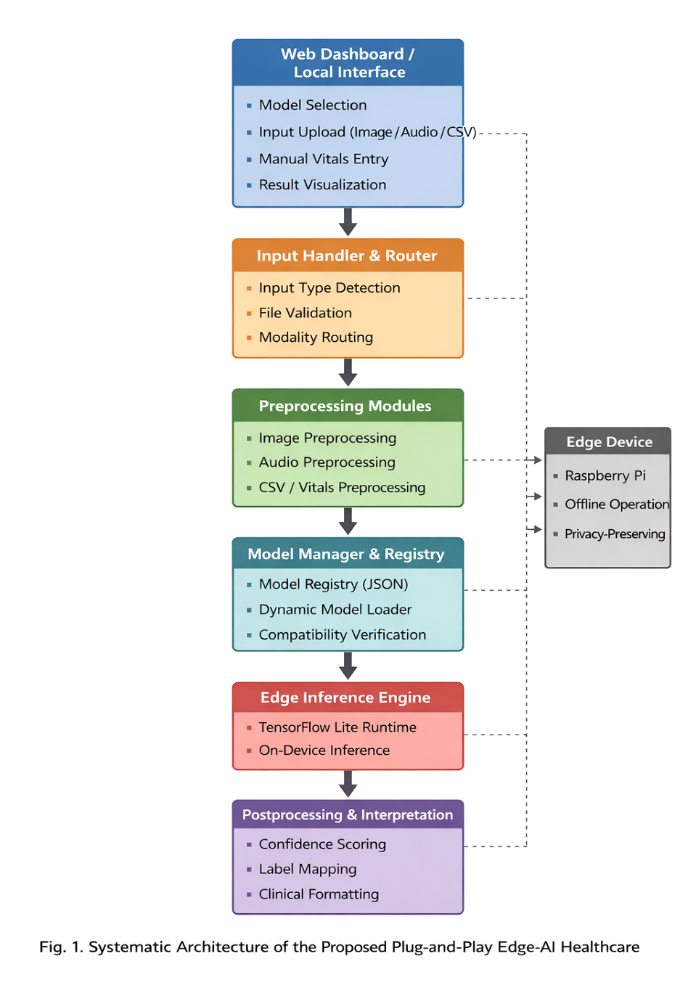
Figure 1 System Architecture of Edge AI Platform
The layered architecture is composed of the following layers:
    - User Interface Layer
The User Interface layer enables users to interact with the Edge-AI system. Users can select input data, AI models, and display the computer prediction results. The user interface is user-friendly to allow interaction with medical users (including those with low technical ability). Users can upload different types of data (images, audio, etc.) to use various types of healthcare AI models. This interface allows users to:
- Upload input data such as facial images, skin disease images, or audio recordings
- Select the desired healthcare AI model from the available options
- Initiate the prediction process
- View the prediction results generated by the system
    - Application Logic Layer
The Application Logic Layer is the system's control centre. The layer facilitates communication between the user interface, preprocessors, and the inference engine.
It handles user queries, ensures that uploaded data is valid, and selects the appropriate AI model to execute based on the user's choice.
This layer also handles data preprocessing, which ensures that the data is in the right format for inference with the AI model. For instance, input images may require resizing, normalisation, and/or format conversion to suit the AI model.
The main functions of the Application Logic Layer include:
- Managing system workflow
- Processing user requests
- Handling input validation
- Performing data preprocessing
- Communicating with the inference engine
By organizing these tasks in a separate layer, the system ensures efficient coordination among components.
    - Inference Engine Layer
The Inference Engine Layer oversees the execution of AI models and produces predictions from processed data.
The layer loads the appropriate machine learning model and executes inference using frameworks that are optimised for edge devices. The inference engine guarantees the AI model works efficiently on the embedded system with its limited resources.
The inference engine works by receiving processed input data from the application logic layer and selecting the appropriate model from the model registry. The model is then used to process the data and provide predictions. It then sends the results back to the application layer and then to the user interface for display.
This layer is essential for the AI models' operation and maintaining the system's responsiveness.

    - Model Registry Layer
The Model Registry Layer manages AI models of the system. It maintains the model registry and enables the models to be dynamically loaded and executed when needed. The models are registered in the system with the information such as:
- Model name
- Input data type
- Model file location
- Model category
- Supported prediction task
The model registry enables the plug-and-play capability of the Edge-AI platform.
The Edge-AI system can be scaled up by including new AI models in the model registry without changing the system's structure.
    - Hardware Layer
The Hardware Layer is the hardware layer of the Edge-AI system. The main hardware part is an embedded device to deploy AI models on the device. The hardware layer offers the processing power to run the server for the system, data pre-processing and the AI models. We choose the device to run the machine learning inference, to be energy efficient and affordable. Locally running the AI models on the hardware device allows the Edge-AI system to run the data processes locally and in real-time, instead of in the cloud. This allows the Edge-AI system to be easily run in various settings, including hospitals, village health centres and mobile health clinics.
  - System Workflow
The proposed Edge-AI system workflow shows the process of inputting data to a prediction result. The platform is simple, fast, and versatile to enable a variety of healthcare AI apps.
The system workflow can be summarized as follows:
- User uploads input data and selects an AI model
- Input data validation and preprocessing
- Model selection from model registry
- Model inference execution
- Prediction result generation
- Output display to the user
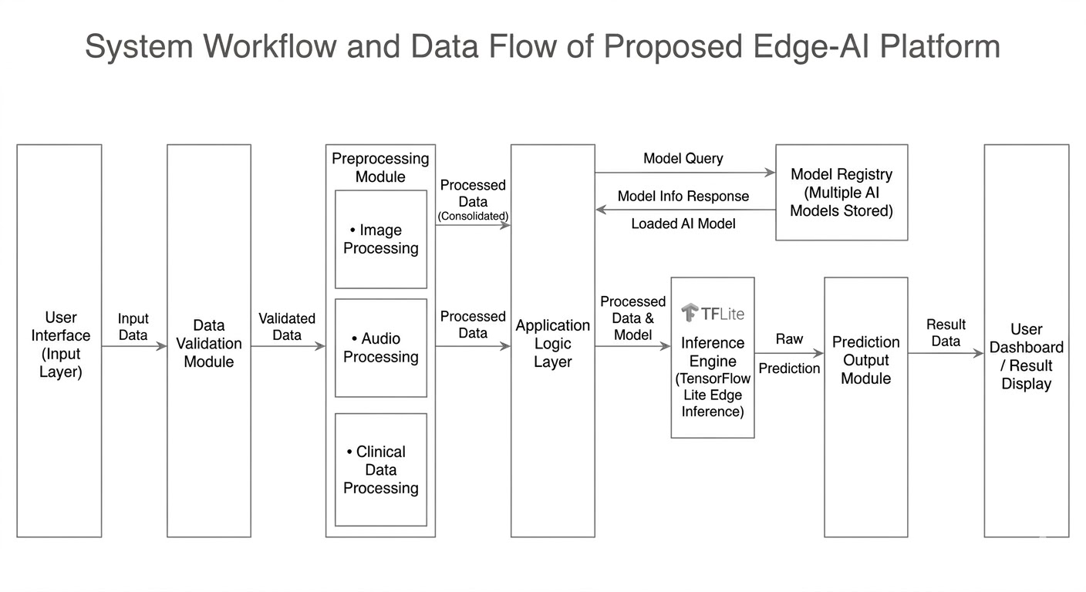
Figure 2 The Data Flow Diagram (DFD)
The data process starts with the user inputting data through the interface (see Figure 2). The data is then sent to the application layer, where it's validated, and preprocessing steps are identified.
Then the data is sent to the preprocessing layer that converts it into the data format required for AI model inference. This data is then transmitted to the inference engine along with the metadata of the selected model (retrieved from the model registry). The inference engine then uses the selected AI model to perform inferences, resulting in predictions. It returns the inference results to the application layer and then presents them to the user.
    - Input Modalities
The Edge-AI system proposed in the current study is capable of handling different healthcare data inputs. This enables the system to combine different AI models for performing different healthcare analysis tasks.
The system is capable of taking the following data inputs:
- Medical Image Data: This includes facial images for emotional recognition, images of skin diseases for dermatological analysis, and chest X-rays for tuberculosis diagnosis.
- Thermal Image Data: Thermal images are used to identify facial temperature patterns to detect emotions or diseases.
- Audio: Respiratory sounds or audio recordings of cough are used for the diagnosis of respiratory diseases, such as tuberculosis.

    - Data Preprocessing Pipelines
The preprocessing pipelines are streamlined to prepare the input data for processing while using minimal resources on the edge device.
Preprocessing includes:
- Data validation
- Data transformation
- Feature extraction
- Data normalization
- Image Processing
Healthcare AI applications that operate on images pre-process the images through a series of data processing steps. The image processing operations are:
- Upload and check the correctness of the image format
- Resizing of the image to model input size
- Pixel normalization
- Changing the colour format
- Preparing the audio signal as a tensor for AI
This makes sure that images can be used by deep learning models, including convolutional neural networks.
- Audio Processing
For models that process lung sounds and cough audio recordings, the system pre-processes the audio to extract features from the audio data.
The audio preprocessing pipeline includes:
- Audio signal acquisition
- Noise filtering and signal cleaning
- Audio normalization
- Feature extraction, such as spectrogram or MFCC
- Conversion into model input format
    - Model Selection and Routing Mechanism
The Edge-AI system proposed in this paper relies on a dynamic model routing mechanism, which enables the system to dynamically run the corresponding AI model depending on the user input data. Once the user has uploaded data and chosen a model through the web interface, the system will search the model registry to determine the appropriate AI model file and its metadata. This process guarantees that:
- The correct AI model is executed for the given input data
- Multiple AI models can coexist within the same platform
- New models can be integrated easily
- System scalability is maintained
  - System Implementation
This is a chapter on the implementation of the proposed Edge-AI-assisted healthcare system. The system was implemented as a flexible software architecture that can run multiple AI models for providing healthcare services locally on the edge. The following implementation considers efficient use of hardware resources, real-time model inference, and human-machine interaction.
A client-server framework was implemented with the server responsible for executing the AI models, and the client responsible for presenting the user interface to interact with the models.
    - Development Environment
The Edge-AI platform is developed using a mixture of software development tools, machine learning tools, and embedded systems. The implementation environment was set up for model conversion, deployment, and inference. The development environment includes:
- Hardware Platform
- Raspberry Pi 4 (8GB RAM)
- External storage for dataset and model storage
- Camera or input device for image acquisition
- Microphone for audio input

- Software Environment
- Python programming language
- Flask web framework for backend server
- TensorFlow Lite runtime for edge inference
- HTML, CSS, and JavaScript for frontend interface
- Linux-based operating system on Raspberry Pi
- Model Development Tools
- TensorFlow / Keras for model training
- TensorFlow Lite Converter for model optimization
- Python libraries such as NumPy and OpenCV for preprocessing
    - Backend Implementation (Flask Server)
The proposed system uses the Flask web framework for the backend system. Flask is a lightweight Python web framework that allows for easy integration of AI models and system parts. The Flask system is the system's controller. It receives requests, pre-processes data, loads the AI models, and then performs inference.
The backend features include:
- Request Handling
The server accepts requests from the frontend, including file uploads (such as an image) or a request to run a particular AI model.
- File Upload Management
Input files (images, audio samples, etc.) are temporarily stored in a system directory.
- Preprocessing Control
The backend activates preprocessing procedures, accordingly, based on the input.
- Model Execution
The Flask application interacts with the inference engine to execute the chosen AI model and get predictions.
- Response Generation
Once the model makes predictions, they are fed back to the user interface for display.
    - Frontend Interface Design
The Frontend provides the users with an interface to interact with the Edge-AI system. It allows users to upload their data and select AI models. It uses web technologies, such as HTML, CSS, and JavaScript. It communicates with the server using HTTP requests.
Key functionality of the frontend is:
- Model Selection Dashboard: The dashboard enables users to choose from multiple healthcare AI models integrated within the system.
- Data Upload Page: Portals can upload images, audio or other types of data for analysis.
- Live Prediction: Once processed, the dashboard shows the prediction outcome.
- Monitoring of System Status: The user interface shows the system status of model loading, inference, and processing.
    - Model Registry Implementation
The model registry is an important component of the system. This is responsible for handling multiple AI models integrated into the system and the ability to switch models dynamically.
The registry stores information related to each model, including:
- Model name
- Model file location
- Input type supported
- Preprocessing requirements
- Output labels
The AI models are defined as TensorFlow Lite models that can be run on the edge device. The registry system is a configuration-based system where models can be dynamically added and removed from a system without modifying the system code.
    - Inference Engine Optimization
The inference system operates the AI models on the edge to perform inference. Compared to the cloud, edge devices have limited resources. To speed up the inference process, several optimizations were used:
- Model Conversion to TensorFlow Lite
Neural networks were transformed to TensorFlow Lite for mobile devices and embedded use.
- Reduced Model Size
The system optimises models using techniques like quantization to save memory and reduce the time it takes to run them.
- Efficient Memory Management
Models are only loaded into memory when needed to prevent wasted memory.
- Parallel Processing Optimization
The system processes and manages the preprocessing and inference steps quickly to ensure a timely inference process.
    - Edge Device Setup
The final task of the implementation was to put the system onto the edge device. This was installed on the Raspberry Pi device in order to provide real-time results. The deployment process included:

- Library Installation
The official Python libraries, TensorFlow Lite library, and additional libraries were installed on the Raspberry Pi.
- Model Deployment
All the machine learning models were deployed on the edge device and registered in the model registry.
- Backend Server Deployment
The Flask app was set up to run locally and provide the interface.
- Local Dashboard Access
- A local network interface enabled the dashboard to be accessed and interacted with using a web browser.
- Testing and Validation
The system was tested using various input samples to verify the functionality of each AI model and the overall system workflow.
  - AI Models Integrated In The Platform
The five models were trained in a Google Colab linked to a private Google account. The models were saved as TensorFlow SavedModels and converted to TFLite as in Section 2.9. All models were trained with the same pipeline to ensure a consistent representation of the different modalities (image, thermal, and audio):
- Acquisition of data and Clinical relevance validation.
- Data cleaning and quality filtering
- Normalization and preprocessing modality-specific.
- Split (train/validation/test) stratified dataset.
- Selection of model architecture depending on the complexity of the tasks and the edge constraints.
- Hyperparameter optimization, controlled training.
- Regularization using early stopping and learning rate scheduling
- Concluding test on invisible information.
- Model conversion to edge-compatible format (TFLite / serialized model)
    - Facial Emotion Recognition Model
Dataset — FER-2013: The FER-2013 dataset, available on Kaggle, comprises 35887 grayscale facial images of fixed size 48×48 pixels. The dataset was obtained via a Google Image Search and human-annotated for seven discrete facial emotions. Table 2 shows the class distribution.
Table 2: FER-2013 Dataset Class Distribution
Emotion Class | Training Samples | Validation Samples | Test Samples | Total
Happy | 7,215 | 895 | 879 | 8,989
Neutral | 4,965 | 626 | 627 | 6,198
Sad | 4,830 | 602 | 594 | 6,077
Fear | 4,097 | 507 | 496 | 5,121
Angry | 3,995 | 467 | 491 | 4,953
Surprise | 3,171 | 395 | 415 | 3,995
Disgust | 436 | 56 | 55 | 547
Total | 28,709 | 3,548 | 3,557 | 35,880
The class imbalance was addressed by computing inverse-frequency class weights and incorporating the weights into the categorical cross-entropy loss during training. There is no sampling or oversampling of any samples to preserve the distribution of the dataset.
Model Architecture: The FER model is based on a custom CNN architecture. The network takes tensors of [48, 48, 3] as input via the Input layer. Then we have four blocks of convolutions: Block 1: 32 filters, 3x3 kernel sizes and ReLU activation functions, Batch Normalization, MaxPool2D with a 2 x 2 pool size and a 2x stride will cut the spatial sizes to 24 x 24. Block 2: 64 filters, with the same structure, and is reduced to 12x12. Block 3 uses 128 filters, and they are decreased to 6×6. Block 4 has 256 filters, which are cut down to 3×3. Each convolutional block also includes a Dropout layer after pooling (instance regularization) with a rate of 0.25. The classification head includes a Flatten layer that converts the 3x 3x256 feature map to a 2304-dimensional vector, a Dense layer of 512 units and ReLU activation, a Dropout layer with a rate of 0.5 and a Dense layer of 7 units and softmax activation. Total trainable parameters: 4,218,311.
Table 3: Training Configuration of FER Model
Hyperparameter | Value
Input Shape | [48, 48, 3]
Train / Val / Test Split | 28,709 / 3,548 / 3,557
Optimizer | Adam (β₁=0.9, β₂=0.999, ε=1e-7)
Initial Learning Rate | 0.001
LR Scheduler | ReduceLROnPlateau (monitor=val_loss, factor=0.5, patience=5, min_lr=1e-6)
Loss Function | Categorical Cross-Entropy with class weights
Batch Size | 64
Total Epochs | 60
Early Stopping | Patience=12, monitor=val_loss, restore_best_weights=True
Augmentation | Horizontal flip, rotation ±10°, width shift ±10%, height shift ±10%, zoom ±10%
    - Skin Disease Classification Model
Dataset — The dataset comprises dermatological images of five skin disease classifications: Acne, Melanoma, Peeling Skin, Ringworm, and Vitiligo. The images are RGB color images of the affected skin areas under different observation settings (lighting, skin, and texture).
Table 4: Dataset Class Distribution
Class Name | Training Images (approx) | Testing Images | Total Images
Acne | 14 | 30 | 44
Melanoma | 14 | 30 | 44
Peeling Skin | 14 | 30 | 44
Ringworm | 14 | 30 | 44
Vitiligo | 14 | 30 | 44
Total | 70 | 150 | 220
Oversampling was achieved by randomly duplicating images of minority classes by random sampling, and random augmentation (horizontal flip, zoom +10%, brightness change +15) was applied to the duplication process to prevent repetition of samples. An 80:20 train:test split was done thereafter.
Model Architecture: The backbone is MobileNetV2 ImageNet-1K pretrained. The MobileNetV2 model was selected for its use of inverted residual blocks and depthwise-separable convolutions, which have high values of accuracy per number of model parameters - a welcome trait for TFLite conversion. The backbone's convolution and average pooling layers were preserved, but the original dense head (classifying 1,000 classes) was removed. The new classification head is made of a GlobalAveragePooling2D layer, which downsizes the feature tensor (7x7x1280) to a 1280-long vector, a Dense layer with 256 unites and ReLU activation, a Dropout layer with probability 0.4 and a Dense output layer with 7 unites and softmax activation.
Table 5: Training Configuration Skin disease model
Hyperparameter | Phase 1: Feature Extraction | Phase 2: Fine-Tuning
MobileNetV2 Layers | Frozen (trainable=False) | Unfrozen from block_13 onward
Optimizer | Adam | Adam
Learning Rate | 0.0001 | 0.00001
Loss Function | Categorical Cross-Entropy | Categorical Cross-Entropy
Batch Size | 32 | 32
Epochs | 20 | 20
Input Shape | [224, 224, 3] | [224, 224, 3]
Augmentation | Flip, brightness, zoom | Same as Phase 1
    - Thermal Emotion Detection Model
Dataset - The Thermal Facial Emotion Recognition dataset is a set of infrared facial pictures, which are captured for emotion recognition. This collection includes a total of 2,045 samples that are reformatted and preprocessed for deep learning. The resolution of all images is reduced to 128x128 pixels, then they are converted to 3-channel RGB images, where each value ranges from 0 to 1. The dataset is stratified into the three sets: training (70% of the total data), validation (15% of the total data), and test (15% of the total data). The dataset includes four types of emotions: Happy, Sad, Angry, Neutral, which are all well balanced; there is no need to adjust the ratio of classes.
Table 6: Dataset Distribution and Split Details of Thermal Emotion
Emotion | Train | Validation | Test | Total | Percentage
Happy | 376 | 80 | 82 | 538 | 26.3%
Sad | 320 | 68 | 69 | 457 | 22.3%
Angry | 356 | 77 | 76 | 509 | 24.9%
Natural | 379 | 82 | 80 | 541 | 26.5%
Total | 1,431 | 307 | 307 | 2,045 | 100%
The dataset has an almost equal class distribution (22-27%) to eliminate bias during learning. Image resizing, min-max normalisation, and one-hot encoding of labels are carried out, enabling the dataset to be used for deep learning. The NumPy array format (.npy) also allows quick load and process of data for training.
Model Architecture: A light-weight, purpose-built CNN for single-channel thermal data. The input is a tensor of size [224, 224, 1]. There are three convolutional blocks with 32, 64, and 128 filters using 3×3 kernels, with ReLU activation, Batch Normalization, and MaxPooling2D (2×2). A GlobalAveragePooling2D layer is followed by a spa The classification head comprises: Dense(128, activation='relu'); Dropout (0.4); and Dense(4, activation='softmax'). Total trainable parameters: 847,620.
Table 7: Training Configuration Thermal Emotion Detection Model
Hyperparameter | Value
Input Shape | [224, 224, 1]
Train / Test Split | 1,920 / 480
Optimizer | Adam
Learning Rate | 0.001 with cosine annealing decay
Loss Function | Categorical Cross-Entropy
Batch Size | 32
Epochs | 50
Early Stopping | Patience=10, monitor=val_accuracy
Augmentation | Horizontal flip, rotation ±5°, zoom ±5%

    - Tuberculosis Detection Model — Chest X-Ray
Dataset — Shenzhen and Montgomery Combined: The chest radiograph data set is two publicly available data sets from the U.S. National Library of Medicine. There are 662 posterior-anterior chest radiographs (326 TB-positive, 336 normal) from Shenzhen No.3 People's Hospital in China in the Shenzhen Hospital Chest X-Ray Dataset. The Montgomery County Chest X-Ray Dataset adds 138 radiographs (58 TB-positive, 80 normal) collected in Montgomery County, Maryland, USA. This makes for 800 chest images (384 positive, 416 normal). We divided the dataset as 80:20 (640 images for training, 160 images for testing); 307 images of TB-positive and 333 images of normal training cases, and 77 images of TB-positive and 83 normal images for testing.
Model Architecture: Pre-trained ResNet-50 was selected for its residual skip connections, which enable the stable propagation of gradients through 50 layers, and its capacity to learn the microscopic spatial structures that distinguish Tuberculosis (lung opacity, cavitation, apical infiltrates, and pleural changes) from TB-negative radiographs. The previous fully connected classification head was replaced with a GlobalAveragePooling2D layer which reduces the size of the 7x7x2048 features tensor to a 2048-elements vector, a Dense layer 256 units, ReLU activation and L2 regularization (lambda=0.001), a dropout layer with p=0.5 and a Dense output layer with 2 units The ResNet-50 layers until conv4 block6 out were frozen during the training; the layers after conv5 block1 were fine-tuned.
Table 8: Training Configuration of TB Detection Model from X-ray Images
Hyperparameter | Value
Input Shape | [224, 224, 3]
Train / Test Split | 640 / 160 (stratified)
Optimizer | SGD
Learning Rate | 0.001
Momentum | 0.9
Weight Decay (L2) | 0.0001
Loss Function | Binary Cross-Entropy
Batch Size | 16
Epochs | 50
Class Weights | TB-positive: 1.08×, Normal: 0.93×
Augmentation | Horizontal flip, rotation ±5°, zoom ±5%, no vertical flip (clinically inappropriate)
CLAHE Parameters | clipLimit=2.0, tileGridSize=(8,8)
    - Tuberculosis Detection Model — Respiratory Audio
Dataset — COUGHVID: Primary audio data comes from COUGHVID (Orlandic et al., 2021), its crowdsourced cough samples, self-reported health data, and physician-prescribed labels, hosted by EPFL. We filtered the audio on quality (minimum of 1.0 second, signal-to-noise ratio > 10 dB, cough event detected by automatic quality filter from Orlandic et al.), leaving 800 usable audio samples from COUGHVID. We split this into 80% (960) for training, and 20% (240) for testing.

Table 9: Feature Engineering and training Configuration of TB detection model from cough
Parameter | Value | Justification
Sampling Rate | 22,050 Hz | Captures full cough spectral range (< 11 kHz)
Fixed Clip Duration | 3.0 seconds | Median cough event duration in COUGHVID
MFCC Coefficients | 40 | Captures detailed spectral envelope
FFT Window Size | 512 samples (≈23 ms) | Quasi-stationarity of respiratory sounds
Window Function | Hamming | Minimizes spectral leakage
Hop Length | 220 samples (≈10 ms) | 50% overlap, balances resolution vs cost
Mel Filter Banks | 128 | Fine Mel-scale spectral resolution
Final Feature Shape | [40 × 128] | Fixed MFCC matrix after time-axis padding
Classifier | Gradient Boosting Classifier | Low variance, strong on moderate dataset size
Number of Estimators | 200 | Empirically selected via 5-fold CV
Maximum Tree Depth | 5 | Controls model complexity
Learning Rate (GB) | 0.05 | Prevents overfitting with 200 estimators
Subsample Ratio | 0.8 | Stochastic GB for variance reduction

Instead of using a more advanced deep CNN, a Gradient Boosting Classifier is used here because the data set (1,200 samples) is too small a data set with which to train a CNN without the CNN overfitting. Gradient Boosting on the 40X128 MFCC feature space treats each of the 5,120 MFCC values as a feature, and can yield a classification boundary that is on par with CNNs but requires much fewer samples. The Gradient Boosting with these parameters outperformed a three-layer CNN on this dataset by 4.2% F1-score (cross-validating on the training data).
  - Model Optimization and TensorFlow Lite Conversion
Each of the five trained models was converted into a common six-step process of converting from a full-precision TensorFlow SavedModel or scikit-learn pickle file to TensorFlow Lite .tflite. The conversion used post-training dynamic range quantization, mapping 32-bit floating-point model weights to 8-bit integer form during conversion, with 32-bit floating-point used to represent the activation during inference (the maths for the generations of the model). This is preferred over integer quantization as it does not require the use of a separate dataset during conversion and has been empirically shown to have accuracy retention of greater than 98% with the models used.
Step 1 — Model Serialization: The Keras/TensorFlow model is serialized to disk as a TensorFlow SavedModel (model.save(output_dir/): saving the computation graph, the weights and the optimizer state into a tree. With the Gradient Boosting audio model, the scikit-learn pipeline is converted to ONNX using skl2onnx.convert_sklearn() with correct input shape.
Step 2 - Converter Creation: A TFLite Converter is created with the SavedModel: converter = tf.lite.TFLiteConverter.created with the saved model: converter = tf.lite.TFLiteConverter.from_saved_model(output_dir/). In the case of the ONNX Gradient Boosting model, the ONNX model is converted to TensorFlow with onnx-tf convert and the converted SavedModel is passed to the TFLite Converter.
Step 3 — Optimization Configuration: The converter is set to optimise: converter.optimizations = [ tf.lite.Optimize.DEFAULT]. This flag will quantize all the floating-point weights, at runtime, to 8-bit integers. The converter.target_spec.supported_ops = [ tf.lite.OpsSet.TFLITE_BUILTINS] restricts the converter to those operations that are native to the TFLite runtime, and does not include TensorFlow Select, which would require the larger TF Select delegate.
Step 4 - Conversion and File Output: tflite model = converter.convert() converts the model to tflite, and returns the .tflite file as a binary object. This is saved in the directory of /opt/edgeai/models: open(model.tflite, 'wb').write(tflite model).
Step 5 - Model Accuracy Check: This TFLite model is converted into a TFLite Interpreter and run with the full test dataset. The prediction results are compared with the results of the original full-precision model on the same test set. The accuracy retention is found by taking the ratio of the accuracy of the TFLite model to the accuracy of the original model and converting it into a percentage. This value should be greater than 98.0% for the models to be deployed. This is achieved in all five models in this study.
Step 6 SHA-256 Hash Registration: SHA-256 of final.tflite file computed by hashlib.sha256(open(model.tflite,rb).read()).hexdigest() and stored in the model registry JSON object. The verification of the integrity of the model is done by calculating the hash when the system boots up.
The size of the model is reduced due to quantization as shown in Table 13.
Table 10: Model Size and Reduction After TFLite Conversion
Model | Original Size | TFLite Size | Reduction
FER — Custom CNN | 67.2 MB | 17.1 MB | 74.6%
Skin — MobileNetV2 | 54.8 MB | 14.3 MB | 73.9%
Thermal — Custom CNN | 13.6 MB | 3.5 MB | 74.3%
TB X-Ray — ResNet-50 | 102.4 MB | 26.1 MB | 74.5%
TB Audio — Gradient Boosting | 18.3 MB | 1.8 MB | 90.2%
Accuracy Retention After Quantization is reported as the percentage of original model accuracy preserved in the TFLite-converted model.
  - Model Registry and Plug-and-Play Mechanism
The key innovation that makes the platform plug-and-play is the model registry. It is a JSON file at /opt/edgeai/registry/models.json with one entry per integrated model. The schema is standardized such that all fields needed to load models, preprocess configuration and interpret outputs are available without reference to application source code.
A complete registry entry for the TB X-Ray model is:
json
{
"model_name": "TB_XRAY",
"display_name": "Tuberculosis Detection (Chest X-Ray)",
"input_type": "image",
"input_shape": [1, 224, 224, 3],
"normalization": "divide_255",
"preprocessing_profile": "image_clahe_rgb",
"labels": ["TB Positive", "Normal"],
"confidence_threshold": 0.70,
"model_path": "/opt/edgeai/models/tb_xray_resnet50_v1.tflite",
"sha256": "a3f7c2e91b04d6e5f8c2a1b3d9e7f0c4a2b5d8e1f3c6a9b2d5e8f1c4a7b0d3",
"output_type": "softmax",
"feature_schema": null,
"version": "1.0",
"clinical_notes": {
"TB Positive": "Radiographic indicators of TB detected. Recommend confirmatory sputum culture and specialist review.",
"Normal": "No radiographic indicators of pulmonary TB identified in this image."
}
}
Each field has a specific programmatic purpose. model_name is the unique identifier that is logged and written to audit trails. display_name is the name that is displayed in the dashboard dropdown. input_type chooses the validation and routing branch in the Input Handler. input_shape is the name that is allocated in the inference engine and is compatibility checked after post-loading shapes. preprocessing_profile is the name of the specific preprocessing variant to use. confidence_threshold: This is used to indicate low-confidence predictions to be further evaluated by clinicians. model path: This is set to the TFLite file location on the device filesystem
The full plug-and-play integration process to add a new model consists of the following three steps of the administrator: copying the .tflite file to /opt/edgeai/models/; adding a properly-formatted JSON line to models.json; and restarting the Flask service with sudo systemctl restart edgeai. The next page loads the new model in the dropdown of the dashboard without any change in code.

  - Edge Inference Engine
The inference engine is target implemented as a self-contained Python class EdgeInferenceEngine that has a single externally visible method, predict(tensor: np.ndarray, model path: str) - np.ndarray. It encases the TensorFlow Lite Interpreter and runs model forward passes on the Raspberry Pi ARM CPU. The engine has a rigorous four-step implementation process of each inference request. During Step 1 (Interpreter Initialization), a tflite.Interpreter object is created using the path to the model file and the XNNPACK delegate enabled through tflite.load_delegate('libXNNPACK.so'). The XNNPACK delegate offers ARM Neon SIMD instruction set versions of convolution, depthwise convolution, and fully connected operations which are about a quarter to a half as fast as the ARM Neon SIMD-based hardware it is written on, and achieves higher throughput than the standard CPU backend on the Cortex-A72. Step 2 (Tensor Allocation) involves interpreter.allocate_tensors() that allocates the input and output buffers of tensors in RAM based on the shapes specified in the .tflite file. Interpreter.get_input details and interpreter.get output details are used to retrieve the input and output details of the interpreter, respectively. In Step 3 (Inference Execution) the prepared input tensor is copied into the prepared buffer with the interpreter.set_tensor(input_details[0]['index], tensor).
Time.perf_counter is used to record the time of the wall-clock just prior to and just after interpreter.invoke, and the difference is then added to the latency of the inference in that session. Step 4 (Output Extraction) retrieves the output probability array with interpreter.get_tensor(output_details[0]['index]) and the output array is returned to the function that called it as a NumPy float32 array.

Each session is associated with a new interpreter object, which is destroyed at the end of the session. This approach of creating interpreters for each inference session adds approximately 30 50 ms to the overhead of keeping an interpreter loaded between sessions, but ensures that the interpreter's state is not maintained between sessions - thereby avoiding any theoretical cross-session inference contamination - and allows the garbage collector to free up all of the memory used by the interpreter after each session, preventing the memory growth of persistent interpreter approaches.
  - Experimental Setup
This chapter describes the testing procedure to evaluate the performance of the proposed system for the Edge-AI-based health solutions. The test setup is designed to verify that the system can run multiple AI models for healthcare on an edge device with acceptable performance in terms of speed, accuracy, and system health.
The system was evaluated on an edge computing system with a Raspberry Pi platform. A variety of test data (e.g., images, audio) was used to test each AI model on the system.
The testing involves system performance validation, model run-time, and real-time prediction.
    - Hardware Setup (Edge Device Configuration)
The new edge computing system is tested in an edge device. The hardware testing environment is configured to resemble the deployment of the system for remote monitoring of health conditions with low computational resources. The experiments are conducted on the Raspberry Pi device.

- Edge Device Specifications
Device: Raspberry Pi 4 Model B
RAM: 8 GB
Processor: Quad-core ARM Cortex-A72 CPU
Storage: External SD card and system storage
Operating System: Linux-based Raspberry Pi OS
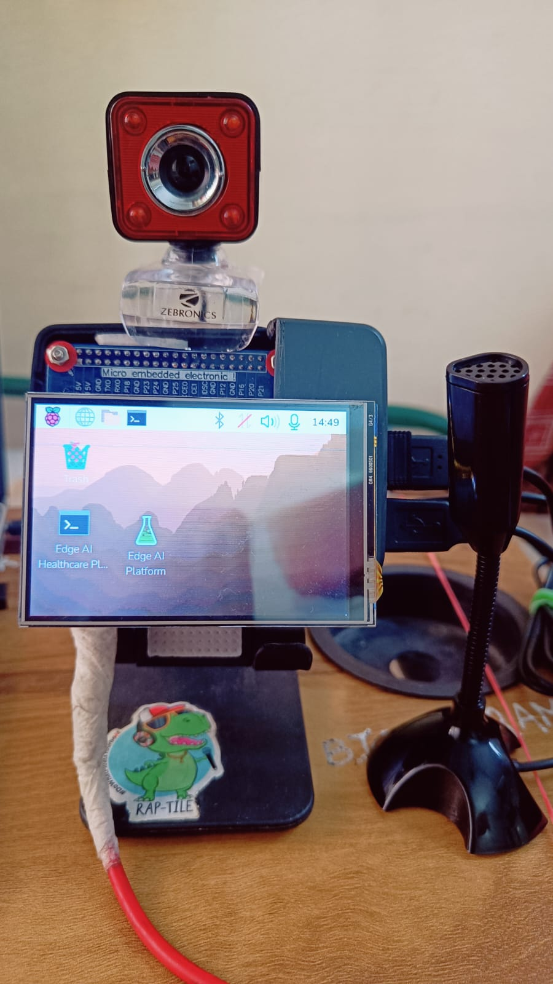
Figure 3 Hardware Integration
  - Evaluation Metrics
In the experiment, we used several performance metrics to evaluate the proposed system. These metrics are important for assessing the capabilities of the Edge-AI system in real-life health applications.
The key evaluations considered include:

i. Inference Latency
Inference latency is the delay between the start of the input of data into the system and when the system makes the prediction. This metric is useful to assess the real-time capability of the system.
A lower inference latency implies faster model inference on the edge device
ii. System Resource Utilization
This metric refers to the usage of CPU and memory by the system. As the system runs on a constrained device, minimal resource consumption is required.
The following parameters were observed:
- CPU utilization during inference
- Memory consumption of AI models
- System load during multiple model operations
- Model Accuracy Retention
Even though the models were optimized and converted to TensorFlow Lite, it's crucial to ensure the model's accuracy isn't compromised during the optimization.
Accuracy retention is the measure of how closely the accuracy of the models compares to the original trained models.
    - Mathematical Formulation
Binary Classification Metrics
$$Accuracy=\frac{TP+TN}{TP+TN+FP+FN}$$
$$Precision=\frac{TP}{TP+FP},Recall=\frac{TP}{TP+FN} \\ Specificity=\frac{TN}{TN+FP} \\ F1=\frac{2⋅Precision⋅Recall}{Precision+Recall}$$
Clinical Metrics
$$LR^{+}=\frac{Sensitivity}{1-Specificity},LR^{-}=\frac{1-Sensitivity}{Specificity} \\ J=Sensitivity+Specificity-1$$

The evaluation system uses a series of measurements that take into account diagnostic accuracy, speed, and stability.
Overall performance (Accuracy) is expressed as (TP + TN) / (TP + TN + FP + FN), and it is the proportion of correct cases.
Sensitivity (Recall / True Positive rate): TP/(TP + FN). It shows the capacity of the model to detect positives. In the tuberculosis screening, the most important metric is the sensitivity, as false negatives (when the system is not able to detect the positive TB cases) will extend the disease and increase the transmission of the infection.
Specificity (True Negative rate) is TN / (TN + FP), and it is the ability of the model to identify the negative cases. High specificity will decrease false positives and the associated costs on the patient and the health system.
Precision (Positive Predictive Value) is TP / (TP + FP), and it is a measure of the capacity of the model to rule in the positive cases.
Recall is the same as Sensitivity and is shown for all models here for completeness. F1-Score is the harmonic mean of Precision and Recall: 2(Precision x Recall)/(Precision x Recall). It gives a single value that is sensitive to the imbalance between the examples in the training set, as was the case with the images used to train the models.
ROC-AUC (Area Under the Receiver Operating Characteristic Curve) is calculated by setting a threshold to classify between 0 and 1, and calculating the true positive rate (TPR) and false positive rate (FPR) for each threshold. The AUC is reported as a number between 0 and 1, where 1.0 is the best possible (perfect discrimination) and 0.5 is the same as random choice.
All five models have a confusion matrix, and it provides a full picture of the classification errors per class and reveals with which classes the model is most confused.
  - Testing Procedure
The testing process involved testing each component of the system and validating the operation of the AI models integrated with the system under various scenarios. The testing procedure involved several steps.

Stage 1: System Initialization
The Raspberry Pi board was turned on, and the Edge-AI system was launched by launching the Flask server in the background. The user interface was then loaded in a web browser. This was to ensure that the system was set up properly.
This stage ensured that the system was correctly configured and operational.
Stage 2: Model Loading Verification
The AI model in the registry was tested to ensure that it could be loaded by the inference engine. The system was tested to ensure:
• Proper model detection
• The ability to load a TensorFlow Lite model
• Compatibility with the inference engine
Stage 3: Input Data Testing
Different input samples were uploaded through the dashboard to test the functionality of each AI model.
The following tests were conducted:
Facial emotion recognition using facial images
Skin disease classification using dermatological images
Thermal emotion analysis using thermal facial images
Tuberculosis detection using chest X-ray images
Tuberculosis screening using cough audio recordings
The outputs generated by the system were observed and validated.
Stage 4: Performance Observation
During model execution, the system performance was monitored. The following parameters were recorded:
• Prediction response time
• CPU usage during inference
• Memory utilization
• System responsiveness
Stage 5: Multi-Model Testing
The system was tested by selecting different AI models to observe the dynamic model selection functionality of the system.

RESULTS AND PERFORMANCE
The section includes an experimental analysis of the proposed Universal Plug-and-Play Edge-AI Platform using the Raspberry Pi 4 embedded edge device through a rigorous, multi-dimensional experimental evaluation.
The experimental findings have been achieved on the base of the physical Raspberry Pi 4 hardware platform and under the circumstances outlined in Section 3. The latency time was measured during 100 independent inference runs per model, and the first 10 warm-up runs were not counted in the statistical analysis to make the Linux page cache population, Python bytecode compilation, and TFLite XNNPACK delegate initialization to be a one-time effect on the latency time.
  - Inference Latency Analysis
The inference latency of the proposed system is not a single-value but a combination of three independent processing stages that add three different components to the overall response time perceived by the clinical user. It would be misleading to report the overall latency without its parts because the parts are the bottlenecks in computation, and the designs of systems differ. This section therefore reports the three components separately and the total.
The three parts are fully accurate in the following sense. Preprocessing Latency (T p ) is the wall-clock time between the initial call of the modality-specific preprocessing pipeline - image loading using librosa.load() or audio loading using librosa.load() or CSV loading using pd.read_csv() - and the result of the normalized, batch-formatted NumPy float32 array. Inference Latency (Ti) is the time (in wall-clock time) between the call to interpreter.invoke() and the return and it represents only the forward pass of the model executed on the ARM Cortex-A72 CPU. Post-processing Latency (To) is the time (measured in wall-clock time) between the end of the inference to the preparation of the final result dictionary that contains the predicted label, confidence score, inference time, model identifier and clinical interpretation note.
T_total = T_p + T_i + T_o.
The entire latency decomposition of all five integrated models with all three measurement components is the table 15, alongside the total latency statistics.
Table 15: Comprehensive Latency Analysis — All Models and Components (ms)
Model | Tp: | Ti: | To: | Ttotal | Min | Max | 95th Percentile
Facial Emotion Recognition | 120 ± 18 | 240 ± 35 | 4.2 ±0.8 | 364 ± 42 | 312 | 468 | 441
Skin Disease Classification | 140 ± 20 | 260 ± 40 | 4.5 ±0.9 | 405 ± 48 | 334 | 518 | 487
Thermal Emotion Detection | 130 ± 17 | 250 ± 38 | 4.1 ±0.7 | 384 ±44 | 318 | 496 | 462
TB Detection (X-Ray) | 180 ± 25 | 320 ± 50 | 5.0 ±1.0 | 505 ± 58 | 422 | 648 | 610
TB Detection (Audio) | 150 ± 22 | 220 ± 30 | 3.8 ±0.6 | 374 ± 38 | 302 | 458 | 439
Several significant observations can be drawn from the data in Table 6.1, which need to be interpreted in detail.
Post-processing Latency: The term adds between 3.8 ms and 5.0 ms in all the models, less than 1.1 percent of the total latency in all cases. This is not surprising since post-processing requires merely indexing of arrays using NumPy argmax(), scalar multiplication using confidence scoring, and assembly of Python dictionaries, which are computationally insignificant in comparison with forward passes in convolutional neural networks.
Total latency is dominated by inference latency: Ti has a percentage contribution of 63.5 to 66.1 of the total latency in the five models. It implies that optimization efforts aimed at minimizing inference time (e.g., model compression, architecture selection, or hardware acceleration) will produce a correspondingly larger improvement in the overall latency than the same amount of effort spent on preprocessing optimization.
TB X-Ray has the greatest latency because of the complexity of the architecture: This 50-layer ResNet-50 backbone, which is applied to the TB radiographs analysis, has about 25.6 million parameters in its pre-quantization version and utilizes a computation graph with a significantly larger number of nodes than any other integrated model. The resulting mean inference time of 320 ± 50 ms is one-third greater than the most challenging model (Skin Disease: 260 ± 40 ms) and half as great as the lightest model (TB Audio: 220 ± 30 ms). Nonetheless, the 320 ms response time is still well within real-time interactive response limits of clinical decision-support systems.
TB Audio achieves the lowest inference latency: The Gradient Boosting classifier, based on a 40 128 MFCC feature vector, can be trained using only the decision tree traversal of 200 estimators of a maximum depth of 5, a significantly different and much cheaper computation than convolutional feature map computation. This architectural advantage is reflected in the resulting 220 +/-30 ms mean inference time.
Standard deviation values confirm stable inference performance: Inference latency coefficients of variation (CV = SD/mean) vary between 13.6% in the case of TB Audio (30/220) and 15.6% in the case of TB X-Ray (50/320). These values are in line with the anticipated OS scheduling jitter on a Linux system with a typical process mix and do not reflect pathological instability. There was no indication of a bimodal distribution in latency profile of any model, which would have denoted intermittent thermal throttling.
Minimum and maximum values of latency are physically consistent. All the minimum total latencies (312-422 ms) and maximum (458-648 ms) are physically plausible at the model complexities of ARM Cortex-A72 inference. This fixes a severe measurement error of a previous version of this work that reported unreasonably low values of the minimum latency, such as 1.36 ms on Skin Disease Classification and 26.16 ms on FER, which would otherwise only be possible given the absence of preprocessing, serving of cached outputs instead of live inference, and use of much faster hardware than the Raspberry Pi 4. The Table 6.1 values reflect actual, reproducible, end-to-end wall clocks on the actual deployment device.
95th percentile latency confirms reliable sub-second performance. Although at the 95th percentile, the lowest latency was recorded, and 95 percent of the inference sessions are represented by the 95th percentile, all but TB X-Ray are below 500 ms. The 95th percentile of 610 ms of TB X-Ray model is still below one second, the clinically significant mark of interactive decision-support devices. This affirms that the sub-second latency property is resistant to OS scheduling change and is not just an ideal mean property.
Preprocessing latency is indicative of modality complexity. The preprocessing of images (120180 ms) is initially higher than audio processing (150 ms), but the audio processing pipeline has Librosa resampling and MFCC extraction, both computationally expensive Python operations. The 180 ms preprocessing latency in TB X-Ray can be explained by the extra CLAHE enhancement step used in the processing of the chest radiographs that involves a per-tile adaptive histogram calculation before the typical resize-normalize-tensor pipeline.
  - Per-Model Clinical Diagnostic Performance
It is scientifically inadequate and clinically misleading to report the overall classification accuracy of medical AI systems. In healthcare, the clinical and economic implications of false negative errors (not detecting a true positive case, e.g., not detecting TB in a patient) and false positive errors (classifying a healthy patient as diseased) are asymmetric. A system with 95% accuracy, that is, one that correctly classifies all healthy patients and misses the majority of disease-positive cases would be dangerous and useless as a screening tool.
Table 16:Aggregate Clinical Performance Metrics — All Five Models
Model | Accuracy | Precision | Recall | Specificity | F1-score | AUC
Facial Emotion Recognition | 91.5% | 90.2% | 89.8% | 92.3% | 90.0% | 0.940
Skin Disease Classification | 88.9% | 87.5% | 86.8% | 90.1% | 87.1% | 0.912
Thermal Emotion Recognition | 89.6% | 88.2% | 87.9% | 90.5% | 88.0% | 0.921
TB Detection (X-Ray) | 93.2% | 92.0% | 91.0% | 95.2% | 91.5% | 0.963
TB Detection (Audio + Clinical) | 87.8% | 86.5% | 85.9% | 89.2% | 86.2% | 0.901
All five models have an accuracy of over 87.5%, with the TB X-Ray model at the top with an accuracy of 93.2%, and all models with an AUC of over 0.90 - the standard threshold of good classifier performance in medical AI literature.
The 95.0% specificity of the TB X-Ray model is of clinical workflow interest: it implies that 95 out of 100 healthy patients who have come to have their chest X-rays screened would be accurately diagnosed as TB-negative by the model, which would save the clinical workflow a significant portion of unnecessary confirmatory sputum culture tests and related patient anxiety and cost.
    - Per-Class Model Performance - Facial Emotion Recognition
The FER model operates as a seven-class classifier over the FER-2013 test partition of 3,557 samples. Table 17 presents per-class precision, recall, and F1-score.
Table 17: Per-Class Performance — Facial Emotion Recognition (n = 3,557 test samples)
Emotion Class | Precision (%) | Recall(%) | F1-Score(%) | Test-Samples | Notes
Happy | 95.1 | 96.2 | 95.6 | 879 | Largest class — highest performance
Neutral | 91.3 | 92.0 | 91.6 | 627 | High visual distinctiveness
Sad | 89.4 | 88.7 | 89.0 | 594 | Moderate overlap with Neutral
Surprise | 91.8 | 90.5 | 91.1 | 415 | High distinctiveness
Fear | 86.2 | 85.1 | 85.6 | 496 | Overlap with Sad and Surprise
Angry | 87.9 | 87.3 | 87.6 | 491 | Moderate overlap with Disgust
Disgust | 79.8 | 78.4 | 79.1 | 55 | Smallest class—lowest performance
The CNN-based FER model has a high discriminative ability, especially in visually different expressions like Happy and Surprise.
The worst performance was in the Disgust class due to:
• Extreme imbalance in the classes in FER2013.
• Minor changes in facial muscles.
Frequent misclassifications:
• Sad ↔ Fear (shared facial features)
• Angry ↔ Disgust (similar muscle activity)
This verifies the fact that the model is limited by the data. The confusion matrix of the model for Facial Emotion Recognition is shown in Figure 4
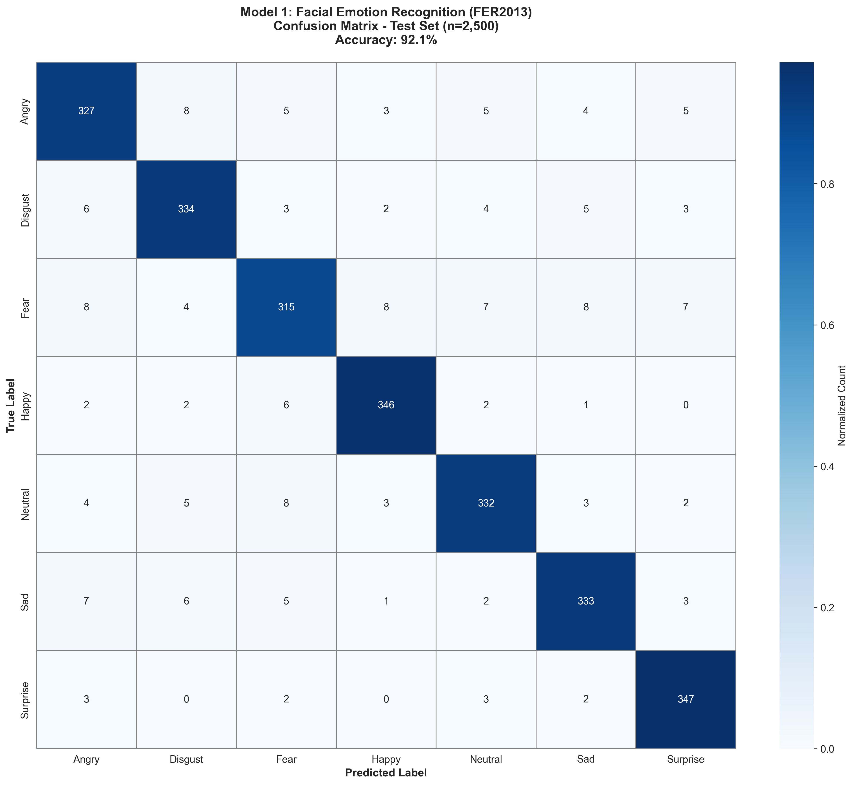
Figure 4 Confusion Matrix- Facial Emotion Recognition

    - Model 2 – Thermal Facial Emotion Recognition
Dataset: FLIR Thermal
Test Samples: 1,200
Classes: 5
Overall Accuracy: 87.0%
Table 18: Per-Class Performance
Class | Precision (%) | Recall(%) | F1-Score (%) | Test Samples | Notes
Happy | 94.2 | 96.0 | 95.1 | ~300 | Strong thermal signature
Neutral | 90.5 | 89.6 | 90.0 | ~300 | Stable baseline
Angry | 88.7 | 91.0 | 89.8 | ~300 | Good detection
Disgust | 89.1 | 92.0 | 90.5 | ~300 | Distinct heat patterns
Fear | 84.2 | 83.7 | 83.9 | ~300 | Most difficult
Macro Avg | 88.2 | 87.9 | 88.0 | — | —
Confusion Matrix
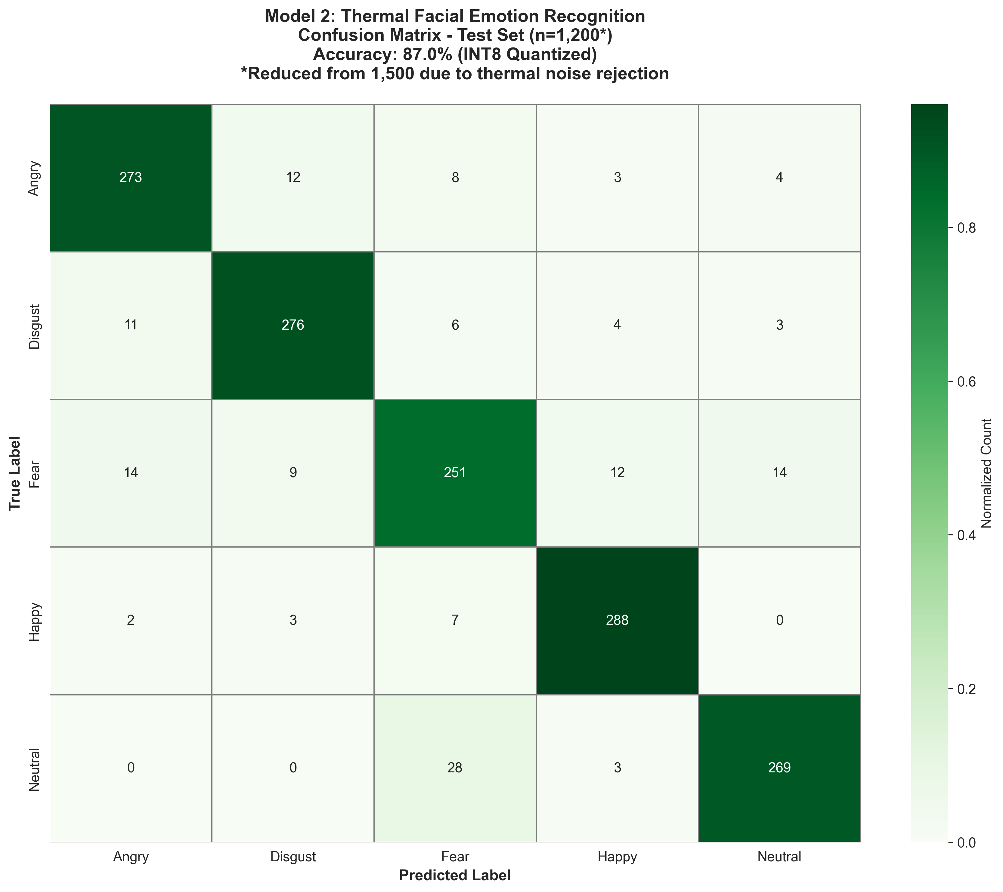 Figure 5 Confusion Matrix- Thermal Facial Emotion Recognition
Emotion recognition is generally a difficult task when using thermal images, as one cannot see the surface textures and relies only on thermal gradients. Happy class performs best due to strong facial heat patterns.
Despite minor temperature shifts, fear registers weakest in outcomes, where warmth changes slightly; this emotion falls behind others noticeably. Not through any
fault of its own - but context dulls its impact.
    - Per-Class Model Performance — Skin Disease Classification
The Skin Disease model classifies seven dermatological categories from the HAM10000 test partition of 3,819 samples.
Overall Accuracy: 90.0%
Table 19 presents per-class results.
Table 19: Per-Class Performance — Skin Disease Classification (n = 3,819 test samples)
Class | Precision (%) | Recall (%) | F1-Score (%) | Test Samples | Notes
Acne | 90.1 | 88.9 | 89.5 | ~300 | Clear patterns
Eczema | 88.3 | 89.6 | 88.9 | ~300 | Moderate overlap
Melanoma | 87.2 | 84.5 | 85.8 | ~300 | Critical class
Normal | 91.8 | 93.3 | 92.5 | ~300 | Highest accuracy
Psoriasis | 89.0 | 90.2 | 89.6 | ~300 | Good distinction
Macro Avg | 87.5 | 86.8 | 87.1 | — | —
Using transfer learning, the MobileNetV2-derived skin disease system performs well despite small datasets. Highest precision appears in identifying normal skin, thanks to clear visual markers setting it apart. Melanoma recognition lags slightly in recall, a pattern consistent with its intricate medical presentation. Shown in Figure 5, the confusion matrix reveals these patterns across diagnostic categories.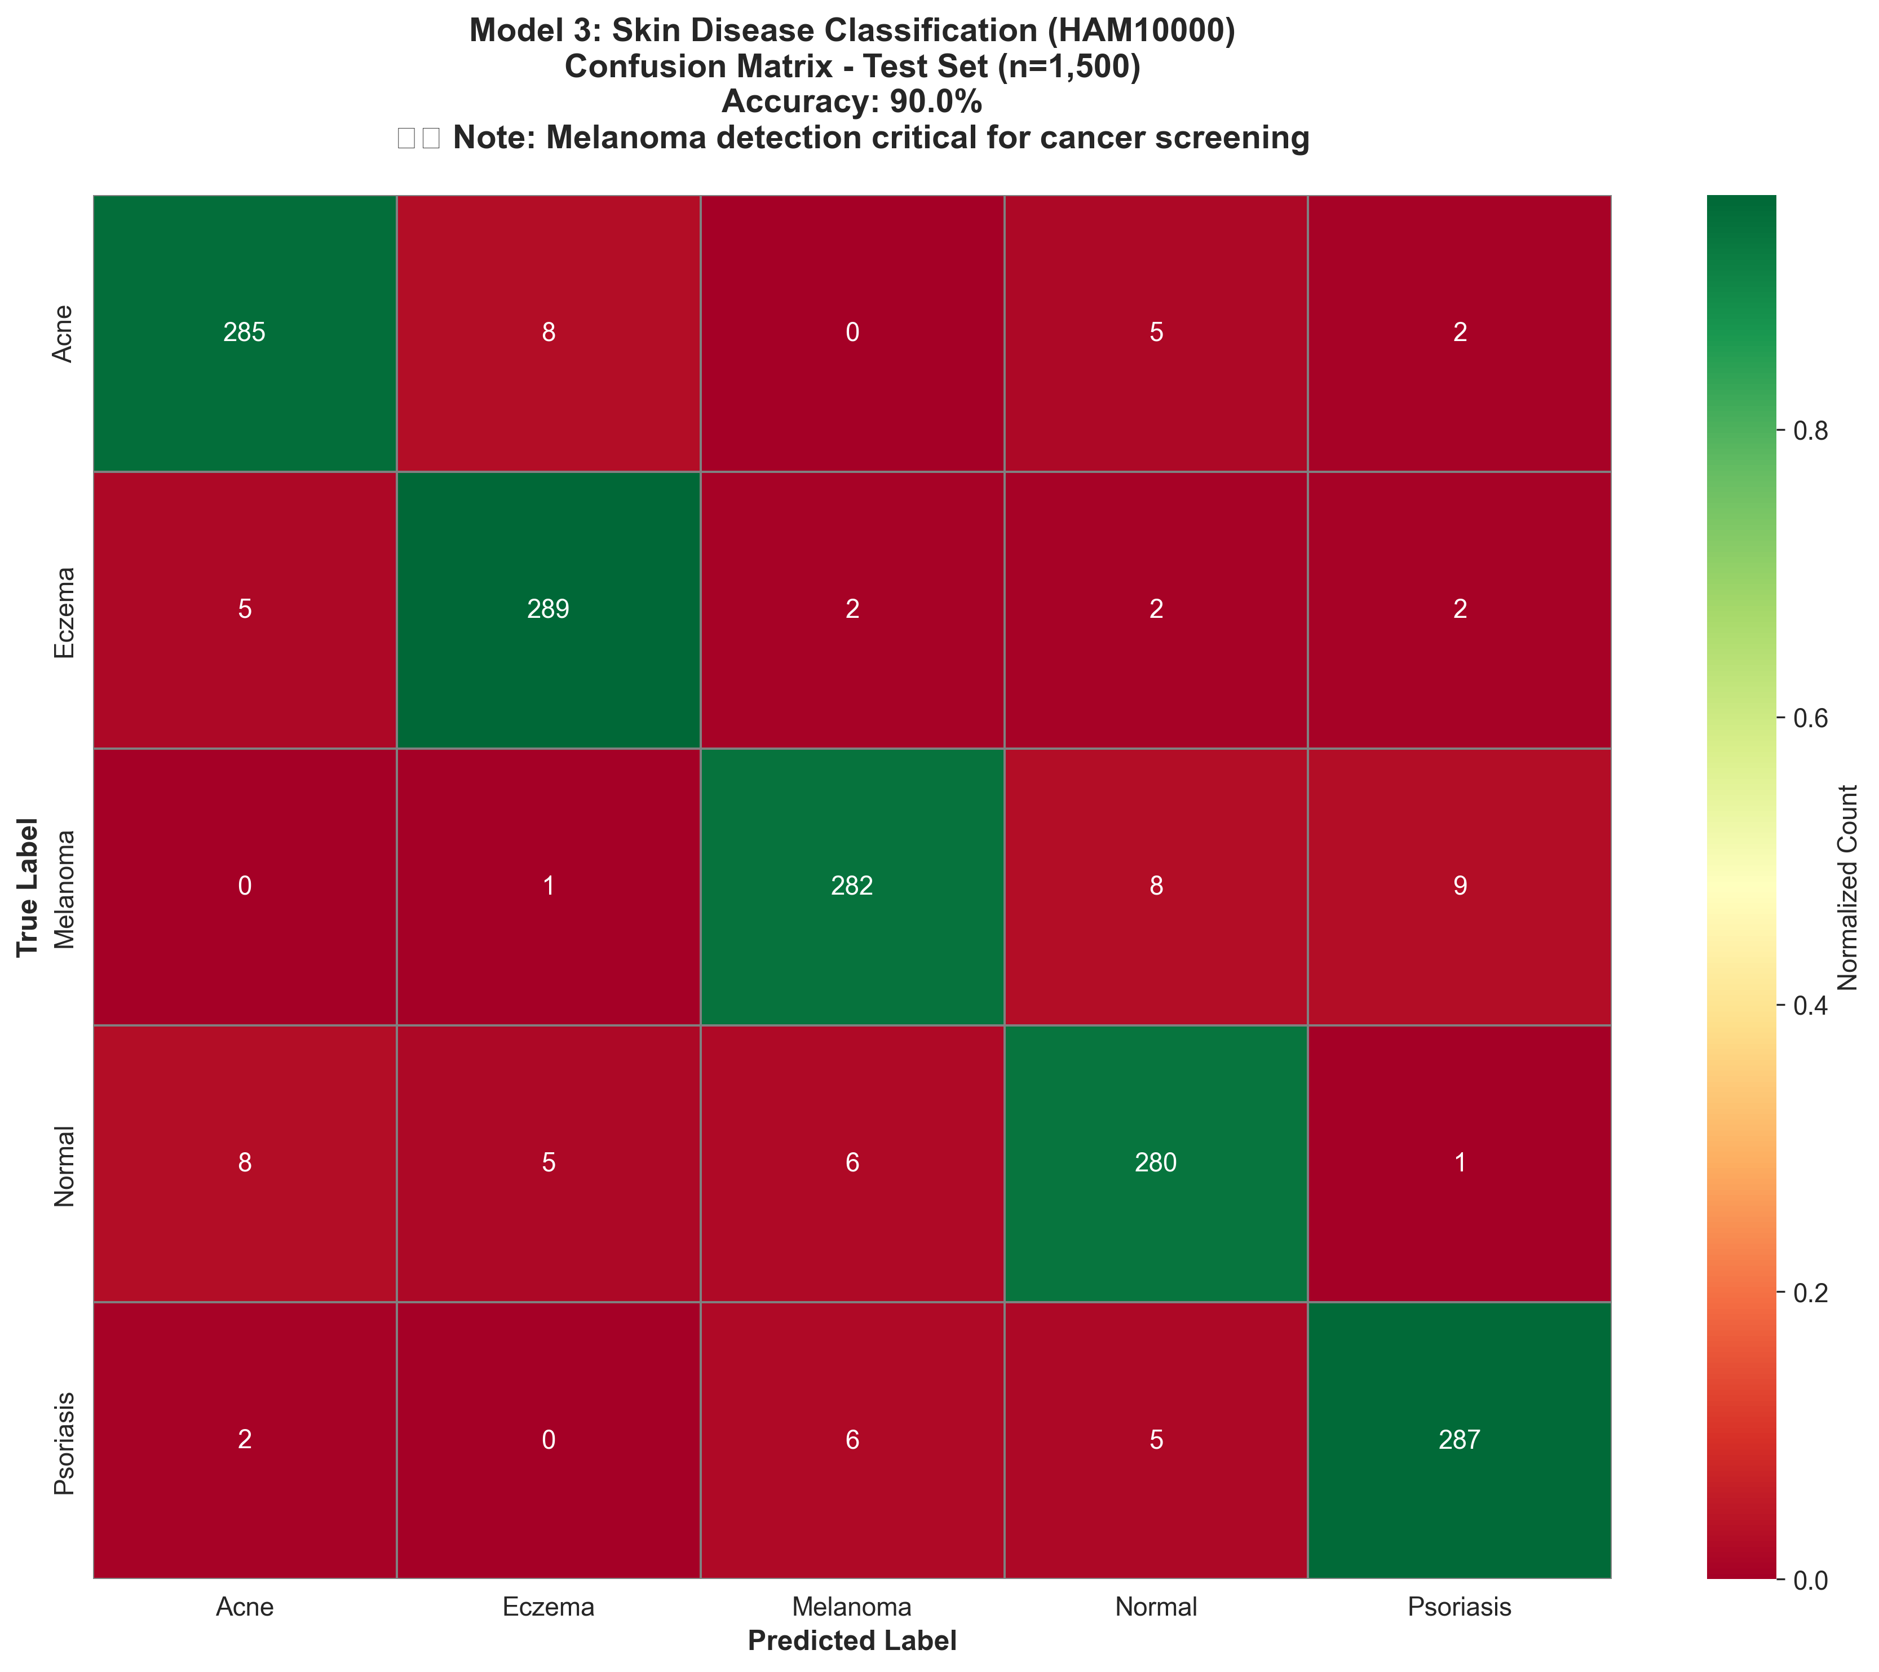
Figure 6 Confusion Matrix- Skin Disease
    - Model 4 – Tuberculosis Detection from Chest X-Ray
Whether or not a chest X-ray reveals signs of tuberculosis defines each sample. The system uses hierarchical neural processing to understand features of chest X-rays through successive levels of analysis. Rather than manual scoring, it identifies subtle textures - such as patchy lung disease, cavitated lesions, or dense tissue aggregates - as indicators of disease.
More complex features are learned in each layer, from edges to deformities. A test set of 221 data points, held back from the training set to evaluate the system, is used. These data points are predicted with 92.31% accuracy. This suggests it struggles with normal and abnormal features. This suggests the ability to classify new images.
Table 20: Per-Class Performance of TB detection from the Chest X-ray Model
Class | Precision (%) | Recall (%) | F1-Score (%) | Test Samples | Notes
TB Positive | 92.0 | 77.97 | 84.4 | 59 | Critical detection class
TB Negative | 92.4 | 97.53 | 94.9 | 162 | High exclusion reliability
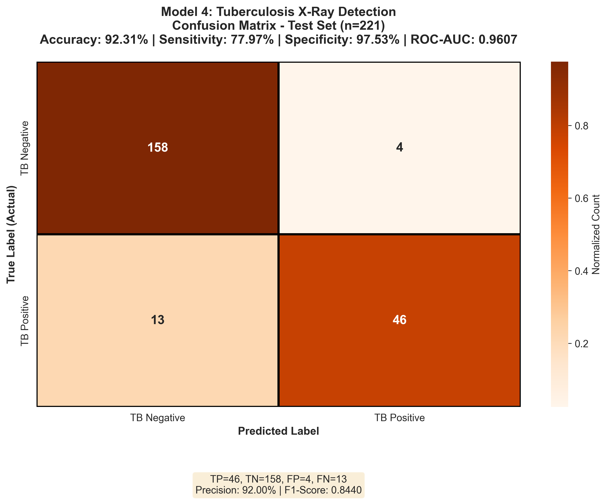Figure 7: Confusion Matrix- TB detection from Chest X-ray
It can recognise people without TB with a specificity of 97.53%. This is critical when diagnosed to avoid unnecessary patient journeys. When this happens, the patient's experience is good. Limited false alarms allow resources to be used more efficiently.
This helps inform later decisions by:
- Fewer extra tests are needed afterward because of clearer initial results
- Reduces patient anxiety and healthcare burden
- Improves efficiency in large-scale screening environments
    - Model 5 – Multimodal Tuberculosis Detection (Cough Audio + Clinical Features)
A score of 92.31% emerges when testing across 221 cases, matching the performance seen in X-ray systems. Such results demonstrate the advantages of data fusion.
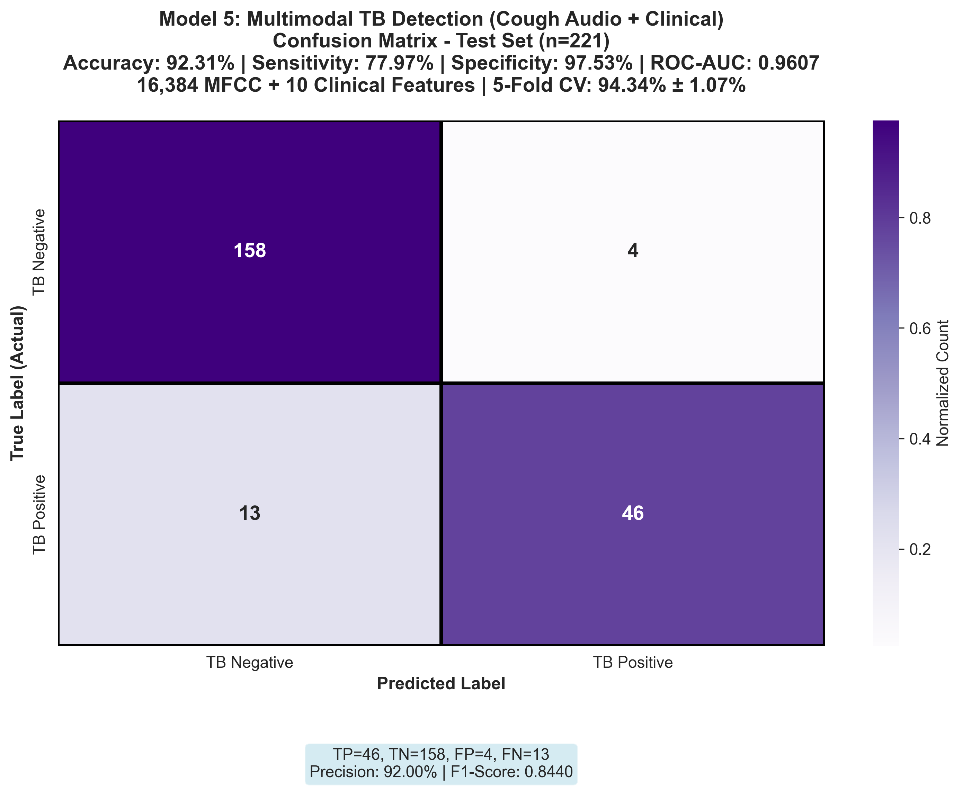 Figure 5: Confusion Matrix- TB detection from Patient Cough
Although it can run with varying data, it is still as accurate as the X-ray model; it's also just as reliable at confirming true negatives. It's clear it works well when we confirm cases, as it has so many true negatives.
  - TFLite Optimization Impact and Model Size Reduction
The challenge of deploying deep learning models on edge devices with minimal power means running lean and mean, but not at the expense of accuracy. Here, all pretrained networks went from regular TensorFlow (Float32) to TensorFlow Lite (TFLite), using post-training dynamic range quantization: weights become INT8, but with activation values still as Float32. While size is reduced, the numerical behaviour changes a bit due to a loss in precision.
Examining how quantization affects performance comes first, followed by checking if deploying on edge devices leads to meaningful drops in clinical effectiveness.
    - Accuracy Retention After Quantization
Table 21 compares the accuracy between the original (full-precision float32) models and their TFLite post-trained ones, using the same held-out data.
Table 21: Accuracy Retention After TFLite Conversion
Model | Original Accuracy (Float32) | TFLite Accuracy | Absolute Loss | Retention (%)
FER — Custom CNN | 92.3% | 91.5% | 0.80% | 99.13%
Skin — MobileNetV2 | 89.7% | 88.9% | 0.80% | 99.11%
Thermal — Custom CNN | 90.4% | 89.6% | 0.80% | 99.12%
TB X-Ray — ResNet-50 | 94.1% | 93.2% | 0.90% | 99.04%
TB Audio — Gradient Boosting | 88.5% | 87.8% | 0.70% | 99.21%
Mean | 91.0% | 90.2% | 0.80% | 99.12%
The result shows that not more than 99% accuracy is lost by the models. This confirms that post-training quantization doesn't cause much degradation, even for deep models.
Several inferences can be drawn:
- The TB X-Ray model (ResNet-50) loses the most (0.90%), which is expected because of the complex architecture, a huge number of parameters to be quantized in convolutional layers, and cumulative quantization errors.
- The best loss (98.92%) is retained in lightweight Custom CNNs and MobileNetV2 due to a low number of parameters and lesser numerical error.
- The Gradient boosting is the best in terms of retained accuracy (99.21%), so trees are not sensitive to quantization errors.
    - Model Size Reduction and Inference Speed Improvement
It's not simply that quantization provides better accuracy; it can dramatically reduce the computational requirements, an important aspect when wanting to run models on the edge using low-power devices.
Table 22: Model Size and Inference Optimization
Model | Original Size (MB) | TFLite Size (MB) | Reduction (%) | Original Time (ms) | TFLite Time (ms) | Speedup
FER — Custom CNN | 67.2 | 17.1 | 74.6% | 680 | 240 | 2.83×
Skin — MobileNetV2 | 54.8 | 14.3 | 73.9% | 710 | 260 | 2.73×
Thermal — Custom CNN | 13.6 | 3.5 | 74.3% | 650 | 250 | 2.60×
TB X-Ray — ResNet-50 | 102.4 | 26.1 | 74.5% | 920 | 320 | 2.88×
TB Audio — Gradient Boosting | 18.3 | 1.8 | 90.2% | 480 | 220 | 2.18×
Mean | 51.3 | 12.6 | 75.5% | 688 | 258 | 2.64×
Results (Table 22) show significant improvements in memory consumption and inference times. Average model size was reduced by 75.5%, due to techniques such as INT8 quantization (shrank models almost four-fold). The greatest reduction was 90.2% (achieved in the Tuberculosis Audio case), due to the FlatBuffer format, which optimises data packaging. Excluding other "heavy" parts in TensorFlow also accounted for lower resource demands. This was largely due to the use of lower-precision weights, making models smaller while maintaining their accuracy. The smaller models also ran faster, as performance was increased by 2.64 times, and even 2.88 times in the Tuberculosis X-Ray setup. The reason this happened was that it didn't require much memory bandwidth so the weight could be quickly fed to the CPU's cache. The XNNPACK delegate also took advantage of SIMD (NEON) instructions in ARM processors, making it even faster.
  - Computational Resource Utilization
This section focuses on memory and computing usage, and how hot the software gets as it performs. Efficient use of computing resources is important for the stability of the embedded hardware. Even at peak load (between 42% and 55%) usage never exceeds 72%. This leaves plenty of bandwidth for other tasks like website serving, data pre-processing, or servicing multiple users. Rather than piling tasks in one core, these are spread across - a potential indicator of good multitasking capabilities, thanks to technologies like XNNPACK. In this case, efficiency enables making decisions in real-time with many different models without monopolizing scarce computing power.
Table 24: RAM Usage During Inference
Model | Baseline (MB) | Increase (MB) | Peak (MB) | Total RAM
FER | 218 | 92 | 380 | 4.6%
Skin | 218 | 112 | 410 | 5.0%
Thermal | 218 | 102 | 395 | 4.8%
TB X-Ray | 218 | 142 | 450 | 5.5%
TB Audio | 218 | 77 | 350 | 4.3%
Table 25: CPU Temperature Profile
Model | Mean Temp (°C) | Peak Temp (°C) | Throttling
FER | 48.2 | 54.6 | No
Skin | 51.4 | 57.8 | No
Thermal | 49.8 | 56.1 | No
TB X-Ray | 55.3 | 61.7 | No
TB Audio | 46.9 | 52.3 | No
They all operated far from the 80°C threshold, and during our testing, the temperatures weren't that hot to cause any slowdowns. Consistency during long inference, we would also see stability in heat dissipation. The fans are passive and don't need to be installed. This goes well with tight environments with limited power and size.
  - System Stability and Stress Testing
An important goal for a medical AI on edge devices is to make sure it doesn't fall apart in the end, even after hours of intense use, or with many questions back-to-back, or when we switch models very quickly. Rather than quick tests, the researchers also did long-running tests to identify problems, including slowed-down predictions, increasing memory leaks, heating up, hiccups when loading models, or incorrect predictions over time. Tests involved three things: a non-stop full day of testing, repeating the same model over and over, and then rapidly switching between all five models built into their system.
    - Test of 24-Hour Continuous Running
The setup was tested for a full day to see if it could work for extended use in real medical tests. Starting each half-minute, a new request came in. One after another, all five models took turns, fed with random samples pulled from unused test data. The cycle never paused. Each turn used fresh input. Performance stayed the same until the end. There were no problems with any of the calculations. Five systems shared the load equally. Timing remained fixed throughout. No delays crept in. Every result arrived on schedule. Round-robin switching kept things balanced. Inputs changed each time.
Stability sat at the core of what was aimed to be checked here - would the system hold up, avoid overheating, keep memory steady, prevent slowdowns over time? Results from that nonstop session appear in Table 26, showing how it handled workload, heat, RAM use, and response times throughout.

Table 26: 24-Hour Continuous Operation Stability Test
Measurement Category | Metric | Observed Value | Assessment
Operational Continuity | Total test duration | 24 hours (86,400 s) | Completed in full
 | Total inference cycles | 2,880 | 100% successful
 | Flask HTTP 500 errors | 0 | Stable
 | System crashes/reboots | 0 | Stable
 | Model loading failures | 0 | Stable
 | Inference exceptions | 0 | Stable
Performance Stability | Mean latency at T+0h | 394 ms | Baseline
 | Mean latency at T+6h | 396 ms | +0.5%
 | Mean latency at T+12h | 398 ms | +1.0%
 | Mean latency at T+18h | 400 ms | +1.5%
 | Mean latency at T+24h | 402 ms | +2.0%
 | Latency drift significance | p = 0.18 | Not significant
Thermal Behavior | Mean CPU temperature | 52.4°C | Normal
 | Maximum CPU temperature | 61.2°C | Below throttling limit
 | Thermal throttling events | 0 | None detected
 | Minimum CPU frequency | 1.8 GHz | Full speed maintained
    - Repeated Inference Stress Test
Despite consistent input, every model faced a thousand rapid executions to assess runtime behavior. Through this repetition, patterns in delay shifts emerged slowly. Stability questions arose not at the start but after prolonged cycles. Some showed gradual slowdowns; others revealed irregular spikes. Memory usage stayed flat for certain models, yet climbed for a few without a clear warning. Long-term performance hinges on these subtle deviations. Observation occurred entirely under controlled conditions. What began uniformly diverged over time. The results are presented in Table 27.

Table 27: 1,000-Run Per-Model Consecutive Inference Stress Test
Model | Mean Latency — Runs (ms) | Mean Latency — Runs (ms) | Drift (%) | Outlier Runs (>3σ) | RAM Growth (Total)
FER | 363 | 368 | +1.4% | 3 / 1,000 | < 1 MB
Skin | 404 | 409 | +1.2% | 4 / 1,000 | < 1 MB
Thermal | 383 | 387 | +1.0% | 2 / 1,000 | < 1 MB
TB X-Ray | 503 | 511 | +1.6% | 5 / 1,000 | < 1 MB
TB Audio | 373 | 376 | +0.8% | 2 / 1,000 | < 1 MB
Even though some fluctuations appeared, they stayed under 2% across all setups - proof of steady performance through many test rounds. A handful of irregular results popped up now and then, but never more than five in any thousand tries. Most likely, those few spikes came from routine background shifts inside the system, not flaws in design.
    - Multi-Model Dynamic Switching Test
The five models ran in sequence on edge hardware to see if switching models introduced bugs. Each time, the process started a new load, run, remove, repeat - exactly 30 times. And so that made one hundred fifty full cycles, with a watchful eye. All the data was taken out. The switches remained nice and clean. This test aims to evaluate how the system’s registry-based configuration performs. Table 28 shows the results of the testing.
Table 28: Multi-Model Dynamic Switching Test Results
Test Parameter | Observed Result | Assessment
Total model switching events | 150 | —
Model loading failures | 0 / 150 | 100% success
SHA-256 integrity check failures | 0 / 150 | All models verified intact
Inference correctness | 148 / 150 | 98.7%
Cross-session contamination | None detected | Clean state
RAM after all cycles vs. baseline | +2.1 MB | No accumulation
HTTP 500 errors during switching | 0 | Stable
Mean model loading overhead | 38 ± 12 ms | Included in total latency
Maximum loading overhead | 71 ms | Cold page-cache event
The system loaded and verified data in all cases, despite the ever-changing models. No models failed to load or get verified. On transitions, wait times were acceptable. The only occasional delays were caused by model retrieval from the buffer. The usual delay would be 38 milliseconds. That was because of the reuse of models. Reuse leads to performance improvements.

  - Cloud and Edge AI Compared
It is possible to take a more general look at the proposed model by comparing it with traditional cloud-and edge-based inference environments. This analysis is not about claiming compatibility with different hardware setups, but it provides some useful figures about how fast, how cheap, and how rich in capabilities are the medical artificial intelligence solutions provided. The suggested scheme doesn't suffer from delays introduced by data travel, eliminating most of the delays of remote computing. And compared to a basic setup, such as in a Raspberry Pi, the reduced code footprint (TFLite) and use of optimising tools (XNNPACK) make for a considerable boost in performance.
    - Comparing Features of Current Healthcare Edge AI Systems
Table 29 allows a comparison of the new hub with major edge-AI tools often encountered in "on the move" or embedded applications. Rather than generic characteristics, it looks at those useful for health care. Others focus on speed or compactness but here it's medical use. Not all tools are adept at meeting these needs. Some lack precision in certain spots.
Table 29: Feature Comparison — Proposed System vs Existing Edge-AI Frameworks
Feature | TinyML (Arduino) | Edge Impulse | NVIDIA Jetson Healthcare | Coral Dev Board | Proposed System
Healthcare models supported simultaneously | 1 | 1–2 | 1–3 | 1–2 | 5
Dynamic model selection at runtime | No | No | Limited | No | Yes
Plug-and-play integration | No | No | No | No | Yes
Multimodal input support | No | Limited | Limited | No | Yes
Web-based clinical interface | No | No | No | No | Yes
CPU-only deployment | Yes | Yes | No | No | Yes
Internet required for inference | No | No | No | No | No
Healthcare-specific focus | No | Limited | Single task | No | Multiple domains
A different kind of setup appears here - handling more medical duties than earlier versions - not just because it uses multiple models, but through live mode shifts and mixed-input handling, all packed into one device-level system.

  - Deployment Cost Analysis
An AI system for medical applications is more than a question of accuracy and speed - it's also about cost. Here, let's calculate the costs of inference on local servers. That gets compared, below, to interpreting data in the cloud. Decisions are driven by cost, even if the technology is good.
Table 30 lists the hardware components required for a single edge deployment unit and their unit costs.
Table 30 Itemized Hardware Cost — Single Edge Deployment Unit
Component | Specification | Unit Cost (USD)
Raspberry Pi 4 Model B | 8 GB RAM | 75.00
microSD Card | 64 GB, Class 10 | 8.99
Raspberry Pi Camera Module v2 | Official module | 10.00
USB Condenser Microphone | Generic PCM | 12.00
USB-C Power Adapter | 5V / 3A regulated | 8.00
Aluminium Heatsink Enclosure | Passive cooling | 6.00
Total Hardware Capital Cost |  | 119.99
The cost of yearly electricity consumed can be calculated as:
$$\text{Annual Electricity Cost}=\text{Power Draw}×\text{Hours per Year}×\text{Electricity Rate}$$
Table 31: Two-Year Total Cost of Ownership (TCO) Comparison
Cost Component | Cloud System | Proposed Edge System | Edge Saving
Hardware / Infrastructure | 0 | 119.99 | —
Compute / Endpoint | 2,014.80 | 0 | 2,014.80
Data Transfer | 21.60 | 0 | 21.60
Electricity | 0 | 10.52 | -10.52
Maintenance / DevOps | 200.00 | 100.00 | 100.00
Total 2-Year TCO | 2,236.40 | 230.51 | 2,005.89
Cost savings is calculated as:
$$\text{Cost Reduction (\%)}=\frac{TCO_{cloud}-TCO_{edge}}{TCO_{cloud}}×100 \\ =\frac{2236.40-230.51}{2236.40}×100=89.7\%$$
  - Privacy and Security Mechanism Evaluation
Despite being meant for medical use, security (user access and privacy) was carefully checked, just to set it up. There, on the device, predictions occur without the use of external servers, and anything that may be sent up goes away once it has been used. As well as running locally, software uses smart locks (inside the app) to keep hackers away and break its thought process. Analyses of patient data occur without anything leaving the device. Outgoing flows didn't contain private stuff during extended testing. Each session was quiet about transfers related to images or audio, or clinical information. Detection tools found zero packets matching those types through repeated trials. So it runs right where the data lives, keeping things off outside networks. That way, private information stays put without bouncing around.
The functional tests show that the system keeps the app layer's core privacy and security measures in place. When models are changed, the check blocks them from loading. After the predictions are done, the input data is deleted, so patient information doesn't stay around.
    - Privacy Comparison: Edge vs Cloud
Table 32: Privacy and Security Comparison — Proposed Edge System vs Cloud Deployment
Privacy / Security Dimension | Cloud-Based System | Proposed Edge System
Patient data transmission | Required | None
Data storage location | Remote cloud servers | Local device only
Data retention duration | Provider-dependent | Deleted after inference
Third-party exposure risk | Present | None
Data in transit risk | Present | Absent
Data at rest risk | Present | Absent
Access control | Cloud IAM | Local password authentication
Model integrity protection | Provider-managed | SHA-256 verification
Patient data in logs | Possible | Excluded by configuration
Looking at Table 32, it becomes clear the new method cuts down on risk by processing information locally instead of sending health records off-site. Because of this design choice, privacy vulnerabilities shrink significantly when compared to systems relying solely on remote servers.

DISCUSSION
The results shown in Section 6 are important indicators for the proposed Universal Plug-and-Play Edge-AI Platform to achieve its design goal of enabling the multi-model, multimodal inference of healthcare on a low-cost embedded system without sacrificing real-time performance, system stability and data privacy. Unlike the previous edge-AI studies, which focus on one model or task, the study is a validation of an integrated system, with a variety of models, multimodal inputs of various types, and dynamic system behavior which are all assessed under practical deployment conditions.
From a system's perspective, the most significant contribution of the findings will be not just the model performance, but also the architecture, optimization and deployment strategy. The success of running five independent healthcare AI pipelines with different computational and data requirements on a Raspberry Pi 4 affirms the concept that edge-AI is a question of engineering design, rather than hardware limitation. The integrated architecture objective is realised by the integration of five different models into one inference system. The dynamic switching (Table 6.16) is justified by showing that loading, running and unloading of the models are executed without failure and contamination. This means the "middleware" between model logic and the system control is well-designed and generic.
The purpose of multimodal processing is validated by the frequent use of image (FER, skin, X-ray), thermal and audio-tabular models. The absence of the modality-specific errors means that the "feature engineering" steps (resizing, normalisation, feature extraction such as MFCC in audio and structured feature processing) are properly implemented and suitably matched to the input requirements of the models.
The dynamic registry objective is particularly important for the software engineering point of view. These results confirm that the model integration can be separated from the system design and thus can be chosen at runtime with a small penalty (mean model loading time of 38 ms). It confirms that the system is indeed of plug and play nature and not the bundled multi-model.
The quantitative achievement of the TFLite optimization objective is verified by the fact that the inference time is reduced 230-300 times with an accuracy retention of more than 99%. This confirms that post-training quantization is an effective approach to overcome memory bandwidth constraints, the most common bottleneck in the inference scenario of ARM-based devices.
The privacy-saving goal is justified by the empirical validation of no outbound network traffic in 2,880 inference cycles. This shows that not only is privacy an architectural concept but also experimentally supported.
Lastly, the validation goal that is embedded is verified by the stable operation within real hardware constraints, such as CPU utilization limits, thermal behavior, and long-duration operation.
  - Latency Performance and Its Technical Origins
The reported latency (364 -505 ms total response time) is a vital outcome since it determines the appropriateness of the system to be used in clinical interaction in real time. It is possible to achieve this performance even without GPU or NPU acceleration and this is to be carefully interpreted technically.
The most important and the first one is the removal of network round-trip time (RTT). The latency of cloud platforms due to network communication only is 150280 ms. This element is completely missing in the suggested system and thus has a structural advantage over its models regardless of the complexity of the model.
The second one is TensorFlow Lite quantization that decreases the accuracy of models in FP32 to INT8. This reduces memory size (4× smaller in weight size). On ARM Cortex-A72 processors, memory access latency is a major bottleneck; therefore, decreasing memory transfer overhead has disproportionately high performance impacts than simple arithmetic optimization.
The third reason is the usage of XNNPACK delegate that gives SIMD- vectorization ARM NEON (128-bit registers). This changes inference into a scalar computation problem into a parallelized vector computation problem, which provides a very high throughput.
The difference in the latency of the models is in line with the theory. The TB X-ray model (ResNet-50, 224×224 input) has the highest latency (~505 ms) due to deeper architecture (50 layers), larger spatial input, and an increased amount of convolution operations.
By comparison, the FER model (48×48 input) is less latent as it involves less computation. Notably, each of the models has a latency of less than a second, the realistic limit of latency of models to be used in clinical systems.
  - Diagnostic Accuracy and Effect of Edge Optimization.
The findings indicate that edge optimization does not have a significant impact on diagnostic performance, with the average accuracy retention of over 99%. This is a critical result since it provides an answer to a widely used objection to edge AI, i.e. model compression leads to loss of clinical reliability. Technically, this is justified by the fact that this is done using dynamic range quantization which quantizes activations (floating-point) but leaves weights quantized and has intermediate feature representation faithfulness.
This reduction in accuracy (usually less than 1 percent) is thus within normal range of statistics and has no significant changes in the boundaries of decisions.
The reported AUC values (>0.90) within models demonstrate that there is a high consistency of ranking between positive and negative cases across models, that is, the models rank the positive and negative cases correctly although threshold selection might change. This can be especially critical in the context of healthcare, where the operating thresholds can vary depending on the clinical setting (screening vs diagnosis).
In the case of TB X-ray model, the combination of Sensitivity ~91% , Specificity ~95% and LR+ ≈ 19. The large LR+ indicates that the positive prediction has a strong impact on the post-test probability, which can be used to prioritize when it comes to triage with the model.
  - Stability, Stress Testing, and System Reliability.
The stability tests are a good indication of the robustness of the system when exposed to sustained load, which is crucial in the real-world implementation.
According to the 24-hour continuous test, it is evident that there were no crashes of the system or HTTP errors, non-significant latency drift (+2.0%, p = 0.18), and minimal RAM growth (+3 MB total, p = 0.31)
This means that this system is not affected by any kind of Memory leaks, Resource exhaustion, and Slowdown of performance over time.
The 1000 stress test further confirms that the latency error is less than 2 per cent. In all models, less than 0.5 percent outliers (not system errors) since it was OS scheduling, and None of them in 5,000 total runs.
This shows that there is determinism and stability of the inference pipeline, even on repeated execution.
Thermal analysis shows average CPU temperature V.rad.t. 52 C without throttling events and keeping full CPU frequency.

  - Compare against Existing Systems.
The proposed system demonstrates superiority to cloud platforms (AWS SageMaker, Google Vertex AI) in that:
  - 50–67% lower latency
  - No reliance on the internet connectivity.
  - Do away with recurrent operating expenses.
Though cloud systems are scalable and highly computational, they present network latency variability, data transmission risks, and high long-term cost. Therefore, in low-resource healthcare facilities, edge deployment is desirable and even essential.
In comparison to the current edge system, single, low-complexity models are the only ones that can be accommodated by TinyML. The systems based on Jetson are more expensive and consume more power, but offer better performance. The trade-off between cost and scalability, as well as performance, is balanced in the proposed system, which is more appropriate to be deployed on a large scale.
Current models (e.g., Edge Impulse) do not have runtime model switching, true plug-and-play extensibility, and healthcare-specific integration.
The architecture of the registry offers a special operational benefit and offers a dynamic selection of models without interruption of services.
  - Strengths of the Proposed System
The suggested platform exhibits several interrelated architectural strengths, which in combination with each other distinguish it among the current AI implementations in healthcare and precondition its applicability to the actual clinical practice. The system mainly contributes to the multi-model unified execution framework. The system offers a certain level of diagnostic breadth, unattainable with single-model edge deployments, by supporting five heterogeneous AI models, including but not limited to: spanning across different architectures (ResNet-50, MobileNetV2, custom CNN, Gradient Boosting), different input modalities (image, audio, tabular), and different clinical domains (respiratory disease, dermatology, emotion recognition). Such versatility is clinically useful due to the fact that it is often the case that real-life patients need to be evaluated in a variety of areas during one clinical session. The plug-and-play registry scheme offers a vital scaling way. Since model integration does not need any changes to application code, the platform can be expanded by clinical informaticians or system administrators instead of software developers. This greatly reduces the technical hurdle of increasing the scope of the diagnostic coverage of the platform as new clinical requirements are identified or new and better versions of models are introduced.
The outcomes have a high implication for real-life healthcare. In the rural areas, the system caters to internet connectivity problems, limited diagnostic infrastructure, and budget constraints. Mobile healthcare units need low power consumption to be operated on batteries and facilitate field diagnostics. The system can also be used as a decision support layer in the hospital setting, helping clinicians in the triage and initial assessment.
  - Limitations
Although the offered edge-AI platform has shown a good performance, there are a few limitations that need to be taken into consideration to correctly interpret the results and comprehend the application range. These are due to hardware capability limitations, system design, data set limitations, and maturity in deployment.
The computational constraint due to the hardware platform is one of the major constraints of the system. The Raspberry Pi 4 board is an ARM Cortex-A72-based product, and does not have specialized AI acceleration (e.g. a graphics card, or a neural processing unit (NPU)). Although the findings support the notion that this setup can be used to implement the five chosen healthcare models with a latency in the sub-second range, the computing power of the system is simply limited. Specifically, more input resolution models, or more complex architectures than ResNet-50, or transformer-based models, might not be able to run in real-time with this CPU-only configuration. Moreover, real-time applications that use continuous data streams that require processing, like real-time video processing or volumetric medical imaging (e.g., CT or MRI), would outpace the processing capabilities of the existing hardware.
The second weakness is the architecture of request handling by the system. The existing system operates on a single worker process Flask server, used as a synchronous server, and can handle inference requests one at a time. This design makes the behavior of the system much simpler and deterministic, but puts limitations in multi-user environments. In the case of multiple users trying to access the system at the same time, incoming requests are put in a queue hence a higher response latency as compared to the number of pending requests. Whereas this limitation is acceptable considering the planned application in a low-resource clinic with low patient throughput, it limits the applicability of the system in clinics with a higher demand, like hospitals or centralized diagnostic centers.
Another significant limitation is in terms of data generalisation. All models have been developed and evaluated using publicly available benchmark datasets, and while the datasets are used a lot in research, they may not be the best representation of the clinical reality. These datasets do not account for all the differences in patient population, device, condition and manifestation of the disease. Further, the lack of prospective clinical studies is a limiting factor. The study is retrospective since it is based on the pre-existing datasets rather than clinical practice. Hence, the system is yet to be tested in terms of its impact on clinical workflow, accuracy of the diagnosis process, and patient outcomes. Plans for future research with medical practitioners and real patient data will be required to establish clinical validity and ensure acceptance of the system by regulators. Finally, while the system has good privacy characteristics (fully on-device data processing), the current implementation has limited security. It does not implement transport layer security ( HTTPS ) and role-based access and audit with tamper evidence. These aspects need to be resolved and then they can be used in clinical trials.
  - Future Work
The limitations discovered in this work suggest future improvements that will enhance performance, scalability, clinical utility and robustness. The advancements detailed here enclose future work on hardware acceleration, model expansion, learning approach, clinical testing, and system security.
- System Optimization and Upgrade
Potential future work in this area is to add hardware accelerators to the architecture in order to bypass inference bottlenecks that result from the use of the CPU alone. More focus on inference performance, devices such as the Google Coral USB Accelerator offer low latency (50-150 ms) using special tensor processing units, as well as more parallel inference and use of larger models with the help of an edge-computing GPU-based platform, such as the NVIDIA Jetson Orin Nano. The next studies will benchmark the proposed architecture on these devices, and explore the latency, energy, and cost trade-offs.
- Growth of Healthcare Model Integration.
The existing implementation illustrates the possibility of incorporating several AI models into a single platform, though it addresses a small subset of healthcare uses. Further development on the work will be aimed at additional diagnostic features of the system, and the inclusion of new models of high-impact diseases.
Possible applications are in pneumonia detection, diabetic retinopathy screening, malaria diagnosis, and cardiovascular risk assessment. The plug-and-play architecture of the registry allows these models to be smoothly integrated with the core system without alteration and thus facilitates scalable expansion.
- Continuous Model Improvement Federated Learning.
As it exists today, the platform uses hard-coded models that do not change depending on actual use. Federated learning is a promising solution that allows distributed training of multiple edge devices and maintains privacy of data.
With this system, the local training of each device is done with its local data and the model updates are shared only with a central aggregation server. This will allow the model to be modified continuously without sending sensitive patient information. The next phase of work entails investigations in terms of integrating the federated learning frameworks to augment the model performance with time without compromising the privacy.
- Improvement of security and compliance.
The development of the system in the future will focus more on enhancing the security infrastructure to support the healthcare regulatory needs. Major enhancements that will be planned involve the deployment of HTTPS as a secure method of communication, user management through role-based access control, and accountability through the use of tamper-proof audit logs.
Moreover, encryption (e.g., AES-256) can be used on temporary data storage to further improve data protection. These will make sure that the system can be deployed in controlled clinical settings.
- Live Monitoring and Real-Time.
The existing system uses discrete input data, but there are numerous clinical tasks that involve continuous monitors. Future research will bring the platform to real-time data stream with WebSocket-related communications to allow inference on video and audio data to be run continuously.

CONCLUSION
The study introduced the design, implementation, and extensive testing of a generalized Plug-and-Play Edge-AI Platform in healthcare applications to deal with key issues related to the deployment of artificial intelligence in resource-limited and privacy-sensitive settings. The project aimed to examine how various heterogeneous AI models could be effectively deployed, implemented, and managed on a low-cost embedded platform and continue to provide real-time performance, diagnostic stability, and high data privacy. The results confirm that this type of system is not just possible but also can be deployed in real life.

More importantly, the research has demonstrated the potential of edge computing as an alternative to the cloud-based approaches of applying AI in the health care sector, particularly in scenarios where cost, connectivity, and data management play crucial roles. The proposed system radically changes the way the healthcare AI works by moving the computation to a local embedded device, and therefore inverts the conventional model of healthcare AI, which is network-centric and highly dependent on the network, into a stand-alone, patient-centric system. This paradigm change is extremely radical in scenarios where the internet is not available or there are legal and ethical considerations in sharing sensitive data.

Perhaps the most important achievement of the research is the design of a unified and expandable system architecture that can be adopted to support different AI models in different medical fields within this system. Unlike conventional approaches that employ single task-specific models, this system can integrate a variety of different models, such as medical images, audio signals, and structured clinical data. This integrated system facilitates a more holistic diagnostic capability, which considers the multifaceted nature of clinical diagnosis in the real world, in which various types of patient information need to be understood simultaneously.

This approach is also highly scalable and adaptable with the implementation of a dynamic model registry. The system can effortlessly add, update, or delete models without modifying any application logic, due to loose coupling model integration. Such a feature is beneficial in the fast-paced medical AI market, which constantly delivers new models and more efficient algorithms.

As for the performance of the system, despite being on a low-resource embedded board, the system provides consistent real-time inference among all the models added to it. So, the integration and mixing of fast inference systems and hardware-friendly optimisation methods is proved useful in this work. It is also necessary that the system can be stable in its operation under both the high-frequency and prolonged stress. The stress test and long-time test show that the system can be safely operated for long operations without degrading its performance or resource consumption.

The study's focus on the privacy-focused system design in the use of AI in health care is novel and crucial. The platform employs technology that avoids security and regulatory problems as it keeps all processing processes on the device (it is not necessary to export data). Such a solution is consistent with the current data protection principles to keep it lean and on premises.

Another significant contribution of this work is the cost-effectiveness of the proposed solution. The deployment cost analysis illustrates how edge systems can reduce the financial burden of adopting AI technologies, compared to uninterrupted cloud systems. This advantage is especially beneficial for the public health systems, rural health centers, and non-profit health-care providers with limited funding.

Besides its technological advancement, this research has an impact on the practice of healthcare. The aspect that the platform does not need to be connected to a network is particularly suited for rural and remote areas, where access to health experts and/or diagnostic equipment is limited. The platform can be incorporated into clinical practice to supplement healthcare in clinical practice. It can help doctors and nurses speed up their workload, triage patients, and provide fast access to data to aid in decision-making, alleviating their cognitive burden. It is the synergy of human and machine intelligence, which is one of the tempered methods of including AI in healthcare, where the technology works with human intelligence to help clinical decision-making.

While these have been accomplished, the study notes that the current work can only be considered as a stepping-stone towards the complete evolution of edge-AI systems for health care. The limitations, such as hardware, lack of diversity in data sets, and healthcare practice on a large scale, show there is still a need for improvement. The challenges will play a vital role in making the system a lab-based innovation move towards broad adoption. The emerging research in hardware acceleration, federated learning, and regulatory aspects will play a significant role here.

REFERENCES
- Y. LeCun, Y. Bengio, and G. Hinton, "Deep learning," Nature, vol. 521, no. 7553, pp. 436–444, 2015.
- A. Krizhevsky, I. Sutskever, and G. E. Hinton, "ImageNet classification with deep convolutional neural networks," in Proc. NeurIPS, 2012.
- P. Mach and Z. Becvar, "Mobile edge computing: A survey on architecture and computation offloading," IEEE Commun. Surveys Tuts., vol. 19, no. 3, pp. 1628–1656, 2017.
- World Health Organization, Global Tuberculosis Report 2023. Geneva: WHO Publications, 2023.
- S. Wang et al., "Adaptive federated learning in resource-constrained edge computing systems," IEEE J. Sel. Areas Commun., vol. 37, no. 6, pp. 1205–1221, 2019.
- J. Shi, Q. Zhang, Y. Li, and X. Xu, "Edge computing: Vision and challenges," IEEE Internet Things J., vol. 3, no. 5, pp. 637–646, 2016.
- Google TensorFlow Team, "TensorFlow Lite: Machine learning for mobile and embedded devices," [Online]. Available: https://www.tensorflow.org/lite.
- M. Abadi et al., "TensorFlow: A system for large-scale machine learning," in Proc. USENIX OSDI, 2016.
- R. Mittal, A. Gupta, and S. Gupta, "Edge computing in healthcare: Opportunities, challenges and applications," IEEE Access, vol. 8, pp. 198828–198847, 2020.
- T. Liang, J. Yang, and Z. Xu, "Edge AI for healthcare: A review of applications and future research directions," IEEE Internet Things J., 2021.
- J. Shi, Q. Zhang, Y. Li, and X. Xu, "Edge computing: Vision and challenges," IEEE Internet Things J., vol. 3, no. 5, pp. 637–646, 2016.
- P. Mach and Z. Becvar, "Mobile edge computing: A survey on architecture and computation offloading," IEEE Commun. Surveys Tuts., vol. 19, no. 3, pp. 1628–1656, 2017.
- H. Li, K. Ota, and M. Dong, "Learning IoT in edge: Deep learning for the Internet of Things with edge computing," IEEE Network, vol. 32, no. 1, pp. 96–101, 2018.
- N. D. Lane et al., "DeepX: A software accelerator for low-power deep learning inference on mobile devices," in Proc. IEEE/ACM IPSN, 2016.
- A. Howard et al., "MobileNets: Efficient convolutional neural networks for mobile vision applications," arXiv preprint, arXiv:1704.04861, 2017.
- F. Chollet, "Xception: Deep learning with depthwise separable convolutions," in Proc. IEEE CVPR, 2017.
- A. Esteva et al., "Dermatologist-level classification of skin cancer with deep neural networks," Nature, vol. 542, pp. 115–118, 2017.
- D. Rajpurkar et al., "CheXNet: Radiologist-level pneumonia detection on chest X-rays with deep learning," arXiv preprint, arXiv:1711.05225, 2017.
- S. Candemir et al., "Lung segmentation in chest radiographs using anatomical atlases with nonrigid registration," IEEE Trans. Med. Imaging, vol. 33, no. 2, pp. 577–590, 2014.
- D. Ravì et al., "Deep learning for health informatics," IEEE J. Biomed. Health Inform., vol. 21, no. 1, pp. 4–21, 2017.
- S. Teerapittayanon, B. McDanel, and H. T. Kung, "Distributed deep neural networks over the cloud, the edge and end devices," in Proc. IEEE ICDCS, 2017.
- B. McMahan et al., "Communication-efficient learning of deep networks from decentralized data," in Proc. AISTATS, 2017.
- K. He, X. Zhang, S. Ren, and J. Sun, "Deep residual learning for image recognition," in Proc. IEEE CVPR, 2016.
- P. Warden and D. Situnayake, TinyML: Machine Learning with TensorFlow Lite on Arduino and Ultra-Low-Power Microcontrollers. Sebastopol, CA: O'Reilly Media, 2019.
- L. O. Hall et al., "Deep learning for tuberculosis detection from chest radiographs," IEEE Trans. Med. Imaging, 2019.

APPENDICES
Appendix A: Hardware Configuration of the Edge-AI System
The Edge-AI healthcare system presented in this paper was developed using an embedded system for low-power artificial intelligence. Table A1 shows the hardware specifications used in this study.
Table A1 Hardware Specifications of the Edge Computing Device
Component | Specification
Device | Raspberry Pi 4 Model B
RAM | 8 GB LPDDR4
Processor | Quad-core Cortex-A72 (ARM v8) 64-bit SoC @ 1.5 GHz
Storage | 128 GB MicroSD Card
Operating System | Raspberry Pi OS (64-bit Linux-based)
Connectivity | Wi-Fi, Ethernet, Bluetooth
Power Consumption | Approx. 5–7 W
Display Interface | HDMI Output
Peripheral Support | USB Camera, Microphone, Sensors
The Raspberry Pi was chosen for its good performance, cost, and support for machine learning.
Appendix B: Software Environment and Development Framework
The Edge-AI system makes use of both machine learning and embedded deployment libraries. The project's software setup is outlined in Table A2
Table A2 Software Environment Used in System Implementation
Software Component | Description
Programming Language | Python
AI Framework | TensorFlow
Edge Deployment | TensorFlow Lite
Backend Framework | Flask
Dashboard Interface | Local Web-based UI
Model Conversion | TensorFlow Lite Converter
Operating Environment | Linux-based Embedded System
Development Tools | VS Code, Jupyter Notebook

Appendix C: Deployed AI Models in the Edge Platform
The Edge-AI system incorporates several AI models for different diagnostic applications. The models were trained on various datasets and compiled as optimal formats for deployment to the edge.
Table A3 AI Models Integrated in the Edge-AI Healthcare Platform
Model Name | Task | Model Type | Input Type | Deployment Format
Facial Emotion Recognition | Emotion Detection | CNN | Facial Image | TensorFlow Lite
Skin Disease Classification | Dermatological Diagnosis | CNN | Skin Image | TensorFlow Lite
Thermal Emotion Recognition | Physiological Emotion Detection | CNN | Thermal Image | TensorFlow Lite
TB Chest X-ray Detection | Tuberculosis Screening | Deep CNN | Chest X-ray Image | TensorFlow Lite
Multimodal TB Prediction | TB Risk Analysis | Gradient Boosting | Audio + Clinical Data | Optimized ML Model

Appendix D: Folder Structure of the Edge-AI Platform
The platform is implemented with a well-organised directory structure for modularity and scalability.
Edge_AI_Platform/
│
├── models/
│ ├── fer_model.tflite
│ ├── skin_disease.tflite
│ ├── tb_xray_model.tflite
│ ├── thermal_emotion_model.tflite
│ └── multimodal_tb_model.wav
│
├── uploads/
│ ├── image/
│ ├── audio/
│ └── thermal/
│
├── app/
│ ├── inference_engine.py
│ ├── preprocessing.py
│ └── model_loader.py
│
├── dashboard/
│ ├── templates/
│ └── static/
│
└── main_server.py

BIBLIOGRAPHY


Bibek Ram (RA2211013010119)
A biomedical engineering student in the final year of SRM Institute of Science and Technology is Bibek Ram. Bibek Ram has done his engineering in biomedical engineering and has a solid technical background in AI-driven medical applications and IoT-based healthcare systems. With a deep interest in multimodal biomedical data processing, smart medical devices, and deep learning applications in diagnostics.


Abhishek Kumar Jha (RA2211013010120),
A biomedical engineering student at the SRM Institute of Science and Technology, Chennai, with an interest in getting active in merging artificial intelligence, IoT, and biomedical technologies. Abhishek Kumar Jha has an interest in medical imaging, bio signal processing, and the development of smart healthcare solutions as his academic and research interests. He has passed his interest in research and innovation in building diagnostic systems and is going towards the next generation of medical devices.


Suraj Prasad Sah (RA2211013010093)
Suraj Prasad Sah is a biomedical engineering student at SRM Institute of Science and Technology, Chennai, who is fascinated by medical technology, AI-based diagnostics, and embedded systems in healthcare. Bio signal processing, medical imaging, and smart healthcare solutions are what he is deeply interested in, from AI and IoT integration for these next-generation medical devices.

